Project Report

The Ultimate Supersonic Open-World Hero Game

Submitted by:
Shujat Qamar (Fall-2020-BSCS-113)

Talal Khalid (Fall-2020-BSCS-138)

Session 2020 – 2024

Supervised by
Ma’am Sahar Moin


Department of Computer Science Lahore Garrison University
Lahore

The Ultimate Supersonic Game

A project submitted to the Department of Computer Science In
Partial Fulfillment of the Requirements for the Bachelor’s Degree in Software Engineering By

Talal Khalid

&

Shujat Qamar

Supervisor

Teacher Name

Sahar Moin

Department of Computer Science

COPYRIGHTS

This is to certify that the project titled “Flash Adventures” is the genuine work carried out by Talal Khalid and Shujat Qamar, students of BSCS of the Computer Science Department, Lahore Garrison University, Lahore. During the academic year 2020-2024, in partial fulfilment of the requirements for the award of the degree of Bachelor of Science in Computer Science and that the project has not formed the basis for the award previously of any other degree, diploma, fellowship, or any other similar title.

Shujat Qamar

Talal Khalid

DECLARATION

This is to declare that the project entitled “The Ultimate Supersonic Open-World Hero Game” is an original work done by the undersigned, in partial fulfilment of the requirements for the degree “Bachelor of Science in Computer Science” at the Computer Science Department, Lahore Garrison University, Lahore.
All the analysis, design, and system development have been accomplished by the undersigned. Moreover, this project has not been submitted to any other college or university.

Shujat Qamar

Talal Khalid

ACKNOWLEDGEMENTS

First of all, we both would be highly grateful to Allah Almighty for providing us the patience and helping us stay focused and persevering on this path of difficulties and hard work. We have borne down our efforts in our Final Year Project. We cannot express enough thanks and gratitude to every person who has contributed to the road of the success and completion of our project. We sincerely appreciate and acknowledge the part of all those individuals who played a general role in the completion of our project and would also like to extend our sincere thanks to all of them.
Secondly, we would like to express our deep sense of gratitude and harmony to our beloved Parents who were always there to uphold us morally and financially and showed their generous love and care throughout the entire period of learning. We are highly likely to thank all of the faculty members of Computer Science who have shared their utmost knowledge with us.
Lastly, we would like to express a deep sense of gratitude and honorable thanks to our supervisor and project head Ma’am Sahar Moin, for encouraging us to proceed with this project and providing guidance. She proved herself as a dedicated supervisor and will be a constant source of inspiration for us in the future as well.

DEDICATION

We would like to dedicate this project firstly to Allah Almighty who guided us with high seeking of knowledge and dedication to prosper our mission. Secondly, to our beloved parents who helped us by their support and guidance to always be dedicated and sincere to our goal. In the end, we would dedicate this project to our honorable teachers which increased our knowledge and also to our university, Lahore Garrison University and the Computer Science department.

Table of Contents

Chapter 1 1
Introduction 1
  - Background 1
  - Introduction 2
  - Purpose 3
  - Product Scope 3
  - Report Organization 3
Chapter 2 4
Problem Definition 4
  - Objectives 4
  - Problem Statement 5
  - Solution to Proposed Problem 5
  - Project Milestones and Deliverables 5
Chapter 3 6
Software Requirement Specification 6
  - Introduction 6
    - Purpose 6
    - Document Conventions 6
    - Intended Audience and Reading Suggestions 7
    - Product Scope 8
  - Overall Description 8
    - Product Perspective 8
    - Product Functions: 9
    - User Classes and Characteristics 10
    - Operating Environment 10
    - Design and Implementation Constraints: 11
    - User Documentation 11
    - Assumptions and Dependencies: 11
  - External Interface Requirements 12
    - User Interfaces: 12
    - Hardware Interfaces: 21
    - Software Interfaces: 21
    - Communications Interfaces: 21
  - System Features 22
    - Signup & Login 22
    - Dashboard 22
    - Department Management 22
    - People Management 22
    - Ticket Management 23
    - Payroll Management 23
    - Attendance Management 23
    - Graph Report 23
    - Feedback Section 23
    - Team Calendar 23
    - Logout 23
      - Description and Priority 24
      - Stimulus/Response Sequences 24
      - Functional Requirements 24
  - Other Nonfunctional Requirements 25
    - Performance Requirements 25
    - Safety Requirements 25
    - Security Requirements 26
    - Software Quality Attributes 26
      - Adaptability 26
      - Availability 26
      - Flexibility 26
      - Reusability 27
      - Maintainability 27
    - Business Rules 27
Chapter 4 28
Methodology 28
  - Waterfall Model Working 28
  - Major Milestones 29
  - Platforms and Tools: 30
Chapter 5 32
System Architecture/Initial Design 32
  - System Architecture 32
    - Architecture Design Approach 33
    - Architecture Design 34
      - User interface (UI) Layer 34
      - Authentication Service 34
      - User Management Service 34
      - Ticket Management Service 34
      - Department Management Service 35
      - Human Services: 35
      - Payroll Management Service 35
      - Attendance Management Service 35
      - Reporting and Graph Services: 35
      - Database 36
      - Communication 36
    - Subsystem Architecture 36
      - User Interface Subsystem 36
      - Data Management Subsystem 36
      - Processing Subsystem 37
      - Communication Subsystem 37
      - Security Subsystem 37
  - Detailed System Designing: 37
    - Classification 41
    - Definition 42
    - Responsibilities 43
    - Constraints 44
    - Composition 45
    - Uses/Interactions 46
    - Resources 47
    - Processing 48
    - Interface/Exports 49
    - Detailed Subsystem Design 49
Chapter 6 62
Implementation and Testing 62
  - Software Deployment and Maintenance 67
  - Software Quality 68
Chapter 7 69
Results and Discussion 69
Chapter 8 81
Conclusion and Future Work 81
References 83

List of Tables

Table 1: Document Conventions 7

Table 2: Minimum OS Requirement 10

Table 3: Coding Frameworks and their versions 10

Table 4: Component Classification 41

Table 5: Components Definitions 42

Table 6: Components Responsibilities 43

Table 7: Components Constraints 44

Table 8: Components Composition 45

Table 9: Components Uses/Interactions 46

Table 10: Components Resources 47

Table 11: Components Processing 48

Table 12: Signup/ Signin Test Case 70

Table 13: Admin Dashboard Test Case 71

Table 14: Department Management Test Case 72

Table 15: People Management Test Case 73

Table 16: Ticket Management Test Case 74

Table 17: Payroll Management Test Case 75

Table 18: Attendance Management Test Case 76

Table 19: Graph Report Test Case 77

Table 20: Feedback Test Case 78

Table 21: Team Calendar Test Case 79
List of Abbreviation

Sr No. | Abbreviations | Full Form
1 | RPG | Role-Playing Game
2 | AI | Artificial Intelligence
3 | UI | User Interface
4 | HP | Health Points
5 | XP | Experience Points
6 | NPC | Non-Player Character
7 | MMO | Massively Multiplayer Online
8 | HUD | Heads-Up Display
9 | FPS | Frames Per Second
10 | DLC | Downloadable Content
11 | QA | Quality Assurance
12 | PvE | Player versus Environment
13 | PvP | Player versus Player
14 | RNG | Random Number Generator
15 | UI/UX | User Interface/User Experience
16 | SDK | Software Development Kit
17 | GPU | Graphics Processing Unit
18 | API | Application Programming Interface
19 | DLC | Downloadable Content
20 | TTS | Text-to-Speech

Abstract
Flash Adventures is a groundbreaking open-world superhero game designed to offer players an immersive and thrilling gaming experience. Developed by Talal Khalid and Shujat Qamar as their final year project at Lahore Garrison University, this project represents a fusion of cutting-edge technology and creative storytelling.
The game is set in a vibrant open-world environment where players assume the role of a speedster hero endowed with extraordinary abilities. From navigating bustling city streets to engaging in high-speed combat against formidable foes, Flash Adventures challenges players to harness their powers and protect the city from imminent threats.
Key features of Flash Adventures include dynamic character animations, a compelling narrative with branching storylines, and innovative gameplay mechanics such as super speed and parkour traversal. The game is built using Unity 3D game engine and incorporates advanced visual effects to enhance the sense of speed and action.
With its cross-platform compatibility and dedication to delivering a high-quality gaming experience, Flash Adventures aims to captivate audiences and set new standards in the realm of superhero gaming.

Chapter 1 Introduction

1.1 Background
Flash Adventures emerges from the collective ambition of Talal Khalid and Shujat Qamar, students pursuing their Bachelor of Science in Computer Science at Lahore Garrison University. Inspired by a passion for gaming and a desire to push the boundaries of interactive entertainment, this project represents a culmination of their academic journey, merging technical expertise with creative innovation.
The gaming industry has witnessed an exponential rise in demand for immersive, narrative-driven experiences that transcend traditional gameplay mechanics. Against this backdrop, Flash Adventures seeks to carve its niche by offering players a thrilling journey into the world of superheroes. Drawing inspiration from iconic characters and dynamic storytelling, this project endeavors to deliver an unparalleled gaming experience that captivates audiences across diverse platforms.
1.2 Introduction
Flash Adventures is not merely a game; it is an ambitious endeavor to redefine the boundaries of interactive entertainment. At its core, the project aims to transport players into the shoes of a speedster hero, embarking on a quest to protect their city from looming threats while unraveling the mysteries of their own origin. Through seamless integration of cutting-edge technology and captivating narrative, this game aspires to immerse players in a world where every decision shapes their destiny.
The introduction of Flash Adventures marks a significant milestone in the realm of game development, showcasing the potential of immersive storytelling and dynamic gameplay. By leveraging advanced game design principles and harnessing the power of modern gaming engines, this project endeavors to set a new standard for interactive entertainment, captivating audiences and leaving a lasting impression on the gaming landscape.
1.3 Purpose
The primary purpose of Flash Adventures is twofold: to challenge the conventions of traditional game design and to offer players an unforgettable journey into the heart of heroism. As students of computer science, Talal Khalid and Shujat Qamar recognize the opportunity to apply their technical skills to a creative endeavor that transcends mere academic exercise. By channeling their passion for gaming into a tangible project, they aim to showcase their proficiency in game development while exploring new frontiers of storytelling and gameplay innovation.
Beyond academic pursuits, Flash Adventures represents a labor of love—a testament to the dedication and perseverance of its creators. With a shared vision to craft a game that resonates with audiences on a profound level, Talal and Shujat embark on a journey fueled by ambition, creativity, and a relentless pursuit of excellence.
1.4 Product Scope
Flash Adventures envisages a vast and immersive gaming experience that transcends the confines of traditional superhero narratives. Set in a sprawling open-world environment, the game invites players to explore dynamic landscapes, engage in heart-pounding action sequences, and unravel the mysteries of their character's past. From adrenaline-fueled chase sequences to intricate puzzle-solving challenges, Flash Adventures offers a diverse range of gameplay experiences designed to cater to a broad audience of gamers.
At its core, the scope of Flash Adventures encompasses:
- Seamless integration of narrative-driven gameplay and dynamic open-world exploration.
- Innovative use of advanced game mechanics, including super speed abilities and environmental interactions.
- A rich and diverse cast of characters, each with their own unique backstory and motivations.
- Branching narrative paths influenced by player choices, leading to multiple endings and outcomes.
- High-fidelity graphics, immersive sound design, and intuitive controls to enhance the overall gaming experience.
1.5 Report Organization
This report is structured to provide a comprehensive overview of the Flash Adventures project, covering various aspects of its development and implementation. Each chapter delves into specific elements of the project, offering insights into its conception, design, and execution. The following chapters are included:
- Introduction: Provides a detailed background of the project, outlining its objectives, purpose, and product scope.
- Problem Definition: Explores the challenges and opportunities inherent in developing an open-world superhero game, outlining key objectives and proposed solutions.
- Software Requirement Specification: Details the functional and non-functional requirements of Flash Adventures, ensuring a clear understanding of its technical specifications and design considerations.
- Methodology: Describes the development methodology adopted for the project, highlighting major milestones, tools, and techniques employed.
- System Architecture/Initial Design: Offers a comprehensive overview of the system architecture and initial design considerations, laying the foundation for the game's development.
- Implementation and Testing: Chronicles the implementation process of Flash Adventures, detailing the steps taken to bring the project to fruition and the rigorous testing procedures employed to ensure its quality and stability.
- Results and Discussion: Presents the outcomes of the project and engages in a critical discussion of its successes, challenges, and areas for future improvement.
- Conclusion and Future Work: Summarizes the key findings of the report and outlines potential avenues for further research and development in the realm of game design and development.

Chapter 2 Problem Definition
2.1 Objectives
The primary objectives of Flash Adventures are to:
- Create an exhilarating gaming experience that immerses players in the role of a speedster superhero.
- Develop a vibrant open-world environment filled with dynamic challenges, missions, and opportunities for exploration.
- Implement advanced game mechanics, including super speed abilities, parkour movements, and dynamic combat systems.
- Craft a compelling narrative with branching storylines and meaningful player choices that influence the outcome of the game.
- Utilize state-of-the-art technology and game development tools to ensure high-quality graphics, animations, and sound design.
- Ensure cross-platform compatibility to reach a broad audience of gamers across various devices and platforms.
2.2 Problem Statement
The gaming industry lacks a comprehensive and immersive superhero game that fully embraces the concept of super speed and delivers a compelling narrative experience. Existing superhero games often focus on established characters and storylines, limiting opportunities for innovation and creative freedom. Additionally, many games fail to fully capture the essence of super speed, resulting in gameplay mechanics that feel clunky or unrealistic.
Flash Adventures aims to address these challenges by offering players a fresh and exhilarating take on the superhero genre. By combining dynamic gameplay mechanics with a rich and engaging storyline, this project seeks to redefine the conventions of interactive entertainment and set a new standard for superhero games.
2.3 Solution to Proposed Problem
To tackle the identified challenges, Flash Adventures proposes the following solutions:
- Designing a game world that seamlessly integrates super speed mechanics with open-world exploration, allowing players to traverse the environment with unparalleled speed and freedom.
- Developing a dynamic narrative that adapts to player choices and actions, offering multiple storylines and outcomes based on their decisions.
- Implementing advanced AI systems to create challenging opponents and dynamic encounters that keep players engaged and entertained.
- Leveraging cutting-edge technology and game development tools to ensure high-quality graphics, animations, and sound design that enhance the overall gaming experience.
- Conducting extensive playtesting and feedback sessions to refine gameplay mechanics, balance difficulty levels, and address any technical issues or bugs.
2.4 Project Milestones and Deliverables
The development of Flash Adventures will be divided into several key milestones, each representing a significant stage in the project's progression. These milestones include:
- Conceptualization and Planning: Define the game concept, storyline, and key gameplay mechanics. Establish project goals, scope, and timeline.
- Prototype Development: Create a functional prototype of the game to test core gameplay mechanics and gather feedback from play testers.
- Alpha Build: Develop a feature-complete version of the game with basic graphics, animations, and sound effects. Conduct extensive playtesting to identify and address any major issues or bugs.
- Beta Build: Polish the game with high-quality graphics, animations, and sound design. Implement additional features and content based on player feedback. Prepare the game for release.
- Final Release: Launch Flash Adventures on multiple platforms, including PC, console, and mobile devices. Monitor player feedback and address any post-launch issues or updates as needed.
The project's deliverables will include:
- A fully functional and polished version of Flash Adventures that meets or exceeds the project objectives and requirements.
- Comprehensive documentation outlining the game's development process, including design decisions, technical implementation details, and testing methodologies.
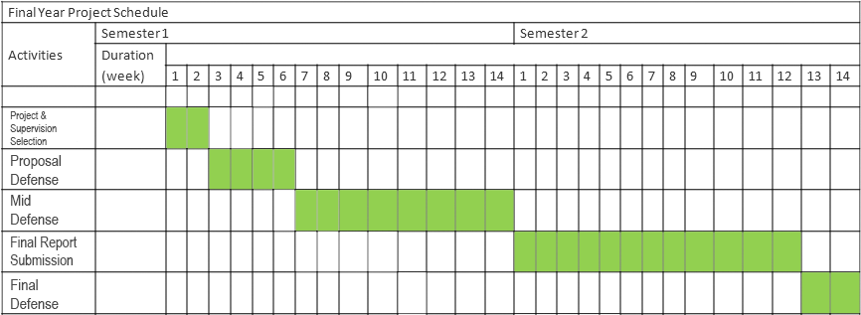
Figure-1

Chapter 3
Software Requirement Specification
3.1 Introduction
The Software Requirement Specification (SRS) for Flash Adventures outlines the functional and non-functional requirements of the game. This chapter provides a detailed description of the project's scope, objectives, and technical specifications, ensuring a clear understanding of the software requirements for development.
3.1.1 Purpose
The purpose of the SRS is to:
- Define the functional and non-functional requirements of Flash Adventures.
- Establish a common understanding between stakeholders regarding the project's scope and objectives.
- Serve as a reference document for developers, designers, and other project stakeholders throughout the development process.
- Provide a basis for project planning, scheduling, and resource allocation.
3.1.2 Document Conventions
The SRS follows standard document conventions, including:
- Clear and concise language to ensure readability and understanding.
- Use of headings, subheadings, and bullet points to organize information and improve navigation.
- Consistent formatting and styling for uniformity and professionalism.

Table 1: Document Conventions

Font | Time New Roman
Font Size: Topic | 20
Font Size: Heading | 14
Font Size: Sub-Heading | 13
Font Size: Paragraph | 12
Font Color | Black
Alignment | Justify
Paragraph Spacing: Before | 6 pt.
Paragraph Spacing: After | 12 pt.
Line Spacing | 1.5

3.1.3 Intended Audience and Reading Suggestions
The intended audience for the SRS includes:
- Developers: To understand the functional and non-functional requirements of the game and guide the development process.
- Designers: To inform the design of game mechanics, user interfaces, and visual elements.
- Project Stakeholders: To gain insight into the project's scope, objectives, and technical specifications.
- Quality Assurance (QA) Team: To create test cases and verify that the game meets the specified requirements.
Reading suggestions for the SRS include:
- Start with the Introduction section to gain an overview of the document's purpose and structure.
- Review the Functional Requirements section to understand the specific features and capabilities of Flash Adventures.
- Refer to the Non-Functional Requirements section for information on performance, security, and other quality attributes.
- Consult the External Interface Requirements section for details on user interfaces, hardware interfaces, software interfaces, and communication protocols.
3.1.4 Product Scope
The product scope of Flash Adventures encompasses:
- A comprehensive and immersive gaming experience that combines dynamic gameplay mechanics with a compelling narrative.
- An open-world environment filled with diverse landscapes, challenges, and opportunities for exploration.
- Advanced AI systems to create challenging opponents and dynamic encounters.
- High-quality graphics, animations, and sound design to enhance the overall gaming experience.
- Cross-platform compatibility to reach a broad audience of gamers across various devices and platforms.
3.2 Overall Description
This section provides an overview of Flash Adventures, including its product perspective, functions, user classes, operating environment, design and implementation constraints, user documentation, assumptions, and dependencies.
3.2.1 Product Perspective
Flash Adventures is a standalone software product designed to provide an immersive and engaging gaming experience. It is not dependent on any other software or system.
3.2.2 Product Functions
The product functions of Flash Adventures include:
- Character movement: Smooth and natural animations for running, jumping, and combat.
- Special abilities: Super speed and parkour mechanics for dynamic traversal and exploration.
- Narrative-driven missions: Diverse mission types including crime-fighting, puzzle-solving, and exploration.
- Adaptive AI: Enemies with unique abilities and coordinated group tactics.
- Interactive dialog system: Meaningful conversations with multiple dialogue options.
- High-quality visuals and effects: Advanced particle effects and high-quality graphics to enhance the sense of speed and action.
Figure-2
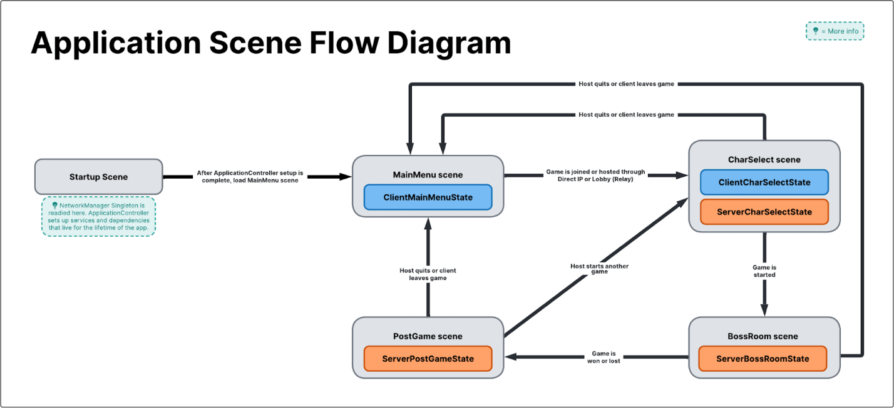

3.2.3 User Classes and Characteristics
The user classes for Flash Adventures include:
- Players: Individuals who interact with the game to enjoy the gaming experience.
- Developers: Individuals involved in the development and maintenance of the game.
3.2.4 Operating Environment
Flash Adventures is designed to operate on multiple platforms, including PCs and major gaming consoles.

Table 2: Minimum OS Requirement

Devices: | Operating  System: | Version: | Processor: | Ram & Rom:
Laptop/PC | Windows | 8.1 | 1.6 GHz | 8 GB & 256 GB
Laptop/PC | Linux | 18.1 | 1.6 GHz | 8 GB & 256 GB
Laptop/PC | MAC | OSX Catalina | 1.6 GHz | 8 GB & 256 GB

Table 3: Coding Frameworks and their versions

Software Technology: | Version:
UNITY | 3.7.0
Visual Studio | Visual Studio 2019
C# | 12.0

3.2.5 Design and Implementation Constraints
Design and implementation constraints for Flash Adventures include:
- Compatibility with different hardware configurations and operating systems.
- Optimization for performance and resource utilization.
- Compliance with industry standards and best practices in game development.
3.3 External Interface Requirements
This section details the external interface requirements of Flash Adventures, including user interfaces, hardware interfaces, software interfaces, and communications interfaces.
3.3.1 User Interfaces
Flash Adventures will feature intuitive and user-friendly interfaces for:
- Main menu: Navigation options to start a new game, load a saved game, adjust settings, and access additional features.
- In-game HUD (Heads-Up Display): Displays relevant information such as health, energy, objectives, and minimap.
- Dialogue system: Interfaces for interacting with NPCs (Non-Playable Characters).

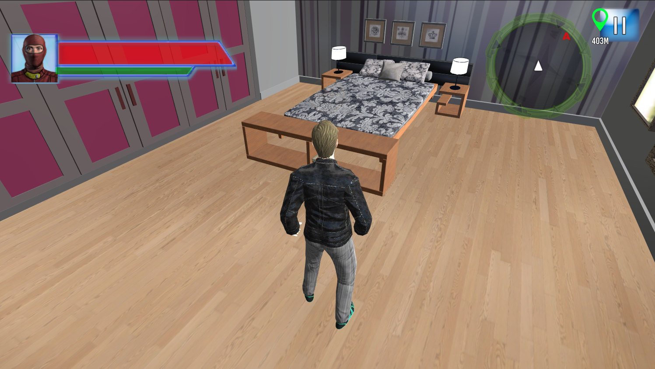

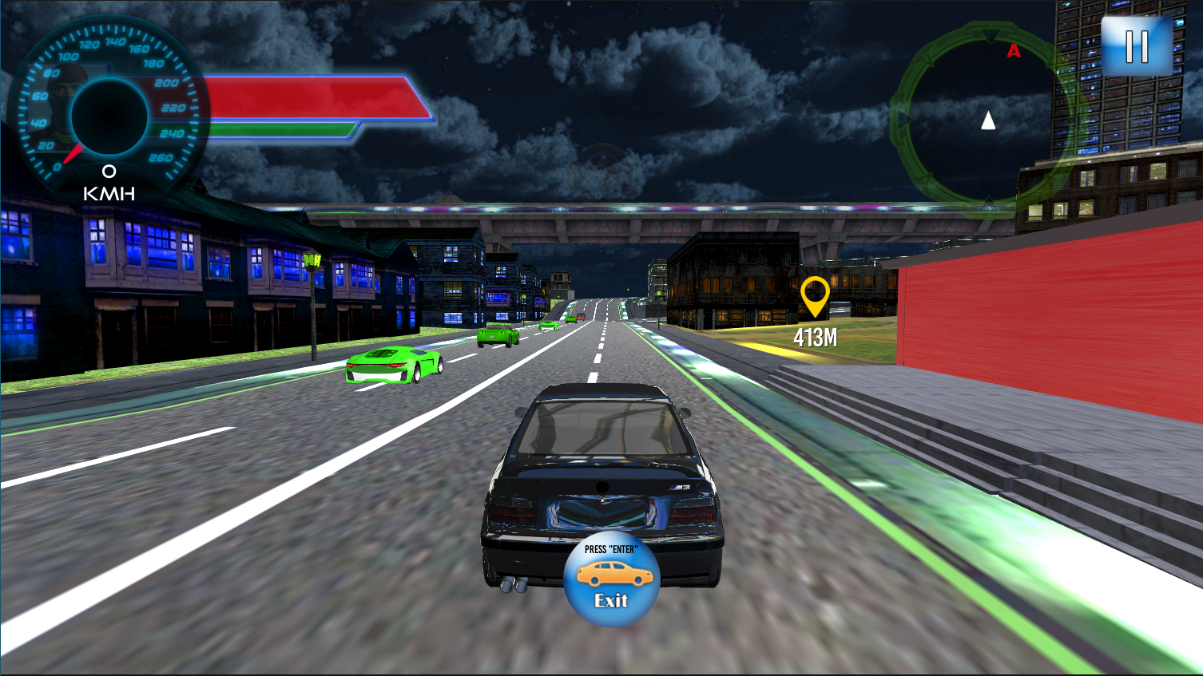

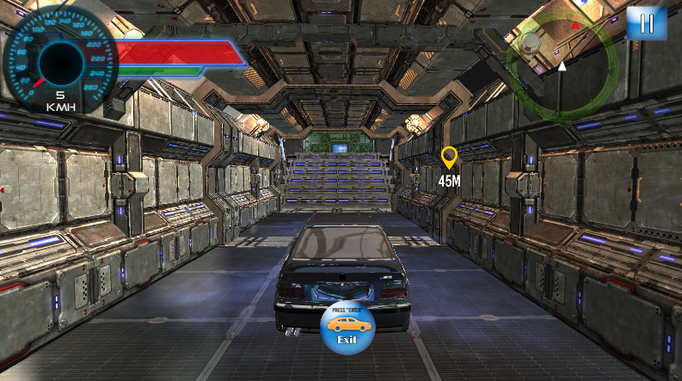

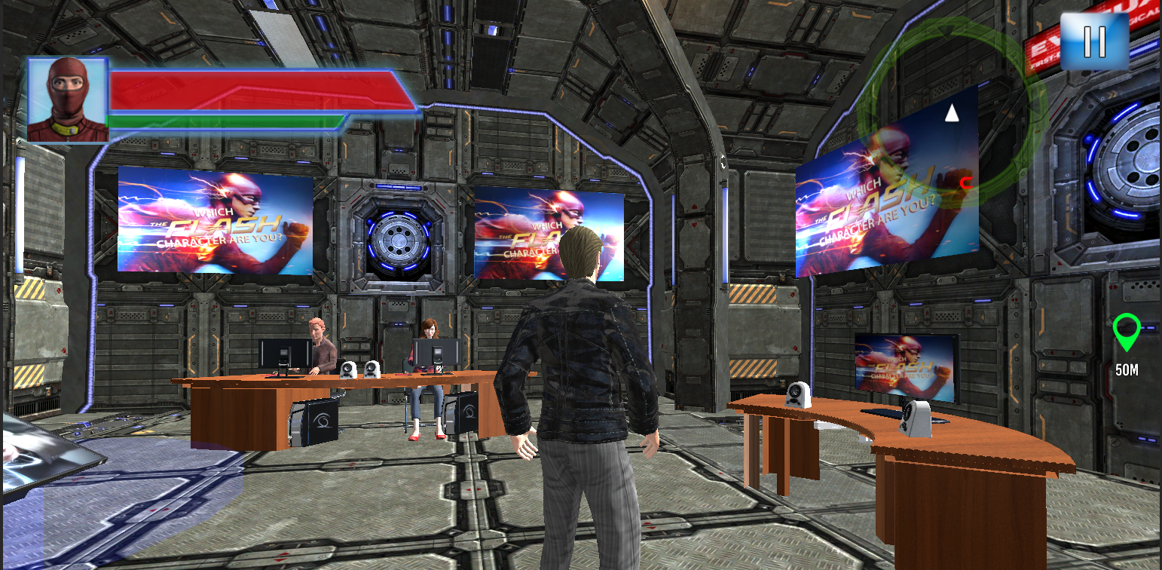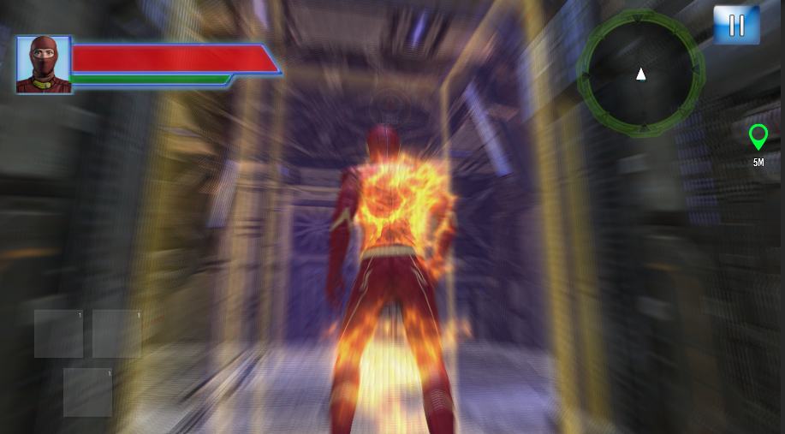

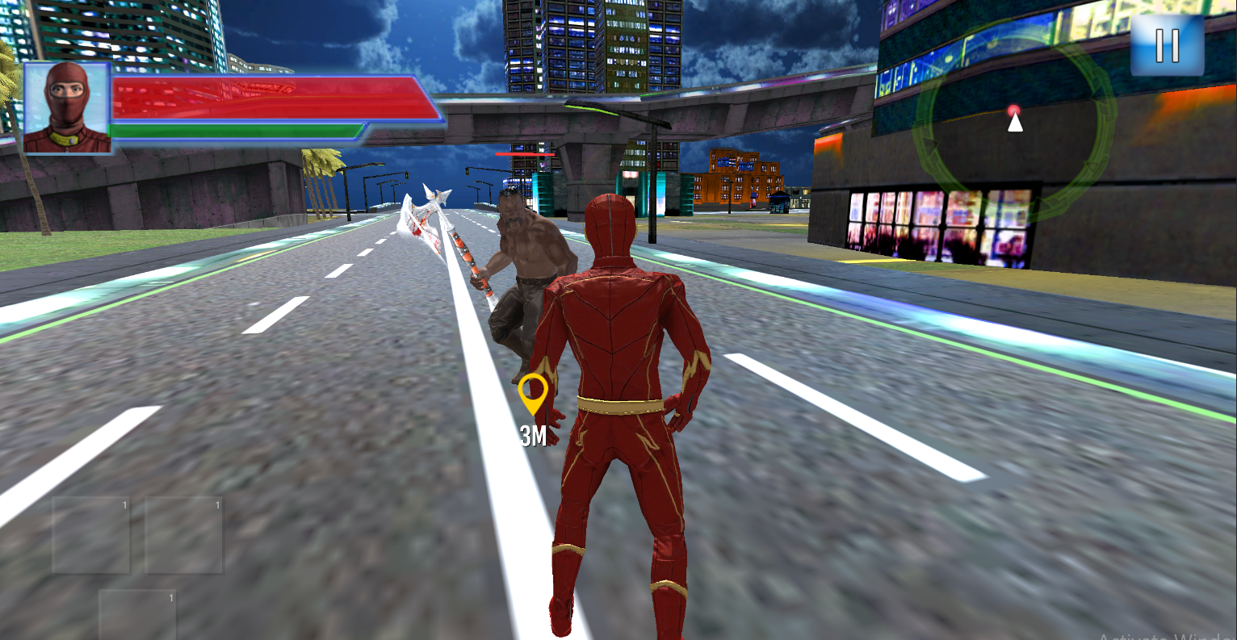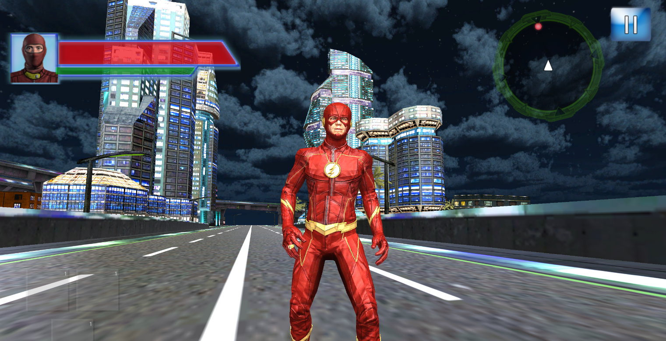

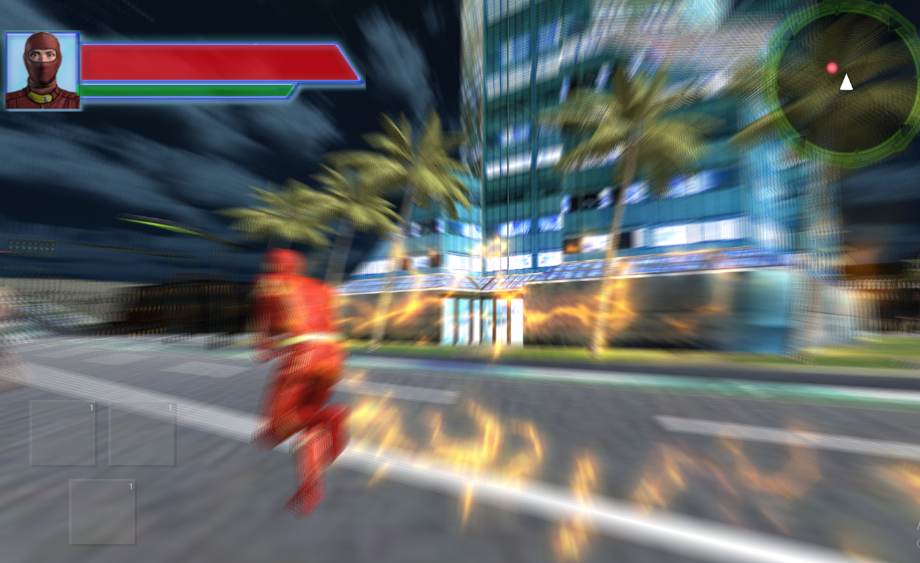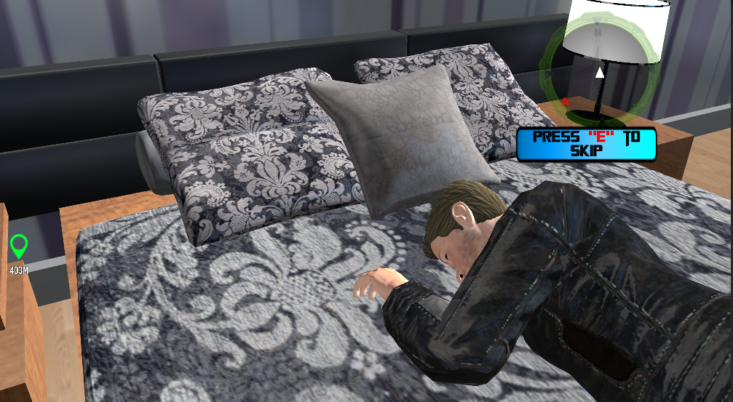

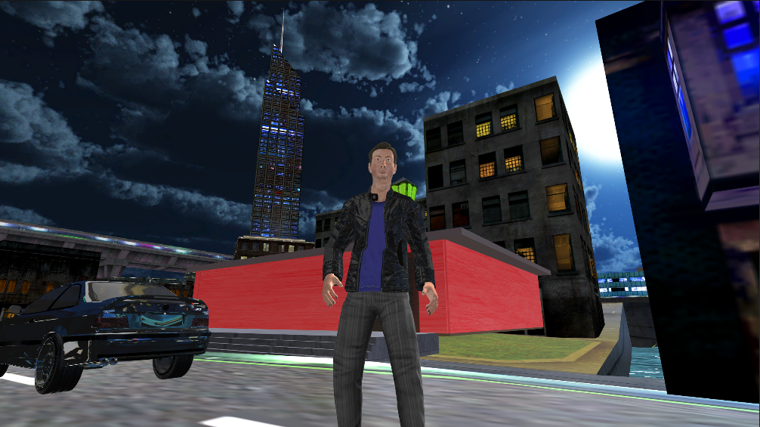

3.3.2 Hardware Interfaces
Flash Adventures will interface with standard input and output devices, including:
- Keyboard and mouse: Input devices for controlling character movement, interacting with the environment, and navigating menus.
- Game controllers: Optional input devices for console versions of the game, providing an alternative control scheme for players.
3.3.3 Software Interfaces
Flash Adventures will interface with external software components and libraries, including:
- Game engine: Integration with Unity 3D for game development and rendering.
- Audio engine: Integration with FMOD Studio for audio processing and playback.
- Networking libraries: Integration with standard network protocols for online multiplayer functionality.
3.4 System Features
This section outlines the system features of Flash Adventures, including signup and login, dashboard, department management, people management, ticket management, payroll management, attendance management, graph report, feedback section, team calendar, and logout.

3.5 Non-Functional Requirements
3.5.1 Usability Requirements
- The user interface should be intuitive and easy to navigate.
- Provide in-game tutorials and tooltips to assist new players.
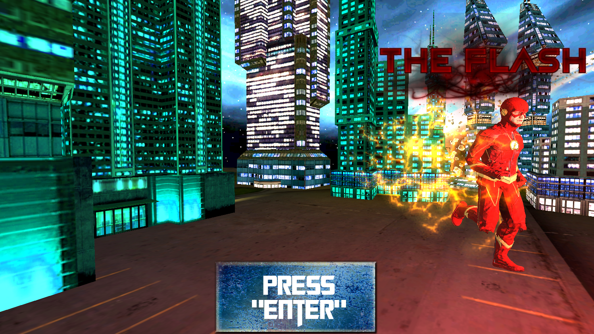
3.5.2 Reliability Requirements
- The game should have an uptime of 99.9%.
- Regular backups of player data must be maintained.
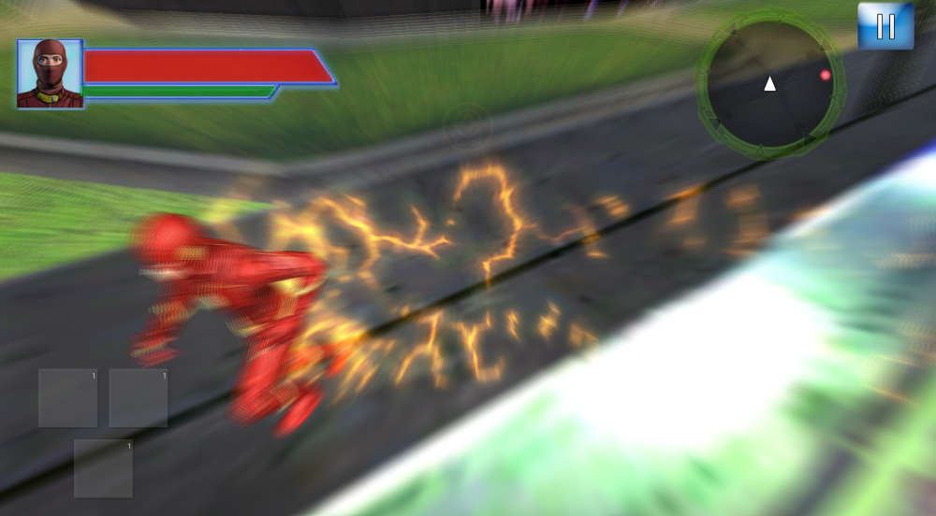
3.5.3 Maintainability Requirements
- The codebase should be modular and well-documented to facilitate easy maintenance and updates.
- Use version control systems to manage code changes.

3.5.4 Compatibility Requirements
- The game should be compatible with major operating systems (Windows, macOS, Linux) and gaming consoles.
- Ensure compatibility with different hardware configurations to provide a consistent experience across devices.
3.5.5 Scalability Requirements
- The system should be able to handle an increasing number of users and concurrent players without performance degradation.
- Design the architecture to support future expansion and additional features.
3.5.6 Localization Requirements
- The game should support multiple languages to cater to a global audience.
- Ensure that text, audio, and visuals can be easily adapted to different cultural contexts.
3.5.7 Ethical Requirements
- Ensure the game promotes positive behavior and avoids content that could be considered offensive or harmful.
- Implement features to prevent and address harassment or toxic behavior among players.
Developing Flash Adventures required a structured and systematic approach to ensure that the project was completed on time and met all the specified requirements. This chapter outlines the methodology used in the project, including the development model, major milestones, and the tools and platforms utilized.

Chapter 4 Methodology
4.1 Development Model: Agile Methodology:
For the development of Flash Adventures, we adopted the Agile methodology. This approach is well-suited for game development projects due to its flexibility, iterative process, and focus on continuous improvement. Agile allowed us to adapt to changing requirements and incorporate feedback from playtesting and user evaluations effectively.
4.1.1 Key Principles of Agile Methodology:
Iterative Development:
- The project was divided into small, manageable iterations known as sprints. Each sprint typically lasted 2-4 weeks and focused on developing specific features or components of the game.
- At the end of each sprint, a potentially shippable increment of the game was produced. This allowed for frequent reassessment of the game's progress and quality.
Customer Collaboration:
- Regular collaboration with supervisors, advisors, and potential users was crucial. This continuous feedback loop helped in refining the game's features and ensuring alignment with user expectations.
- Playtesting sessions were conducted frequently, allowing real users to interact with the game and provide valuable feedback.
Responding to Change:
- Agile methodology embraces changes even late in the development process. This was particularly important for Flash Adventures, as new ideas and improvements were constantly integrated based on play tester feedback and evolving project goals.
- This flexibility helped in accommodating changes without disrupting the overall project flow.

Sustainable Pace:
- Agile promotes maintaining a consistent work pace to avoid burnout. Regular reviews and retrospectives ensured the team worked efficiently and remained motivated.
- Workloads were carefully planned to balance productivity and well-being.

4.2 Major Milestones:

The project was divided into several major milestones, each marking the completion of critical phases and deliverables. These milestones helped in tracking progress and ensuring that the project stayed on schedule.
4.2.1 Project Initiation and Planning:
- Define project objectives, scope, and deliverables.
- Develop a detailed project plan and timeline.
4.2.2 Requirement Analysis and Specification:
- Gather and analyze requirements.
- Develop the Software Requirement Specification (SRS) document.
4.2.3 Design Phase:
- Create the system architecture and initial design.
- Develop detailed design documents for various components.
4.2.4 Implementation Phase:
- Develop the game features incrementally.
- Perform unit testing and integration testing.
4.2.5 Testing Phase:
- Conduct comprehensive testing, including functional, performance, and usability testing.
- Address bugs and issues identified during testing.
4.2.6 Deployment Phase:
- Prepare the game for release.
- Deploy the game to the selected platforms.
4.2.7Maintenance and Support:
- Provide ongoing support and updates.
- Address user feedback and improve the game post-release.
4.3 Platforms and Tools:
To develop Flash Adventures, we utilized a range of platforms and tools to facilitate various aspects of the project, from coding and design to testing and project management.
4.3.1 Development Tools:
- Game Engine: Unity 3D – Chosen for its robust features, cross-platform capabilities, and extensive support for game development.
- Integrated Development Environment (IDE): Visual Studio – Used for coding and debugging.
- Version Control: Git and GitHub – For managing code versions and collaborating among team members.
- Database: MongoDB – For storing game data, including user profiles and game states.
4.3.2 Design Tools:
- Graphic Design: Adobe Photoshop and Illustrator – For creating game assets, including characters, environments, and UI elements.
- 3D Modeling: Blender – For designing and animating 3D models.
4.3.3 Project Management Tools:
- Task Management: Jira – For tracking tasks, managing sprints, and monitoring progress.
- Collaboration: Slack – For team communication and coordination.

Chapter 5 System Architecture/Initial Design
5.1 Overview
The system architecture for "Flash Supersonic" is designed to support an immersive open-world superhero game. The architecture ensures scalability, maintainability, and performance across various gaming platforms. The system leverages modern game development tools and technologies, with a focus on providing a seamless and engaging gaming experience.
5.2 Architectural Diagram

5.2.1 Key Components:
5.2.1.1 Client-Side Application
- Game Engine (Unity 3D)
- User Interface (UI)
- Input Handling
- Rendering Engine
- Audio Engine
5.2.1.2 Server-Side Infrastructure
- Game Server
- Database Server
- Authentication Server
- API Gateway
5.2.1.3 External Services
- Social Media Integration
- Analytics Service
- Payment Gateway
5.3 Component Description

5.3.1 Client-Side Application

Game Engine (Unity 3D)
Role: Core platform for game development, handling physics, rendering, and scripting.
Tools: Unity Editor, Visual Studio.
Physics Engine: Handles collisions, character movements, and environment interactions.
Graphics Renderer: Manages rendering of 3D models, textures, and lighting effects.
AI Engine: Controls NPC behavior and enemy tactics.

User Interface (UI)
Role: Facilitates player interaction with the game.
HUD (Heads-Up Display): Displays health, speed, mission objectives, etc.
Menus: Main menu, settings, inventory, and pause menu.
Dialog Boxes: For narrative interactions and mission briefings.
Role: Processes input from various devices (keyboard, mouse, game controllers).
Customizable Controls: Allow players to configure input settings.
Multi touch Support: For touchscreen devices.

5.3.2 Server-Side Infrastructure

Game Server
Role: Manages game state, multiplayer sessions, and real-time data synchronization.
Session Management: Handles player connections, matchmaking, and session persistence.
Game Logic Processing: Executes game rules and events.
Role: Stores game data, player profiles, and progression.
Data Types:
Player Data: Profiles, achievements, inventory.
Game Data: World state, mission status, leaderboards.

Authentication Server
Role: Manages user authentication and authorization.
Token Management: Issues and validates access tokens.

API Gateway
Role: Routes client requests to appropriate server endpoints.
Load Balancing: Distributes traffic across multiple servers.

5.3.3 External Services

Social Media Integration
Role: Enables sharing of game achievements and content on social platforms.
Content Sharing: Posts achievements and game updates.
Friend Invites: Allows players to invite friends to join the game.
Role: Collects and analyzes gameplay data for insights and improvements.
Technologies: Google Analytics, Unity Analytics.
User Engagement: Session length, retention rates.
Performance: Frame rates, loading times.
5.4 Design Considerations
Approach: Modular design to facilitate the addition of new features and content.
Technologies: Cloud-based infrastructure (AWS, Azure) to handle varying loads.

Performance
Optimization: Profiling and optimizing code, assets, and network communication.
Tools: Unity Profiler, Visual Studio Profiler.
Measures: Implement anti-cheat mechanisms, secure authentication, and data encryption.

Maintainability
Strategy: Adhere to coding standards, thorough documentation, and modular architecture.

5.4.1 Classification

Table 4: Component Classification

Sr No. | Functions | Classification
1 | Sign Up/Sign In | Module
2 | Main Menu | Module
3 | Character Customization | Sub System
4 | Mission Selection | Sub System
5 | In-Game HUD | Sub System
6 | Inventory Management | Sub System
7 | Combat System | Function
8 | Dialogue System | Function
9 | Exploration Mechanics | Function
10 | Save/Load Game | Function
11 | Multiplayer Mode | Function
12 | Settings | Function
13 | Achievements and Rewards | Function
14 | Leaderboards | Function
15 | Logout | Function

5.4.2 Responsibilities

Table 5: Responsibilities
Sr No. | Functions | Responsibilities
1 | Sign Up/Sign In | Stores user records and allows users to access game functionalities
2 | Main Menu | Provides access to different game modes, settings, and other functionalities
3 | Character Customization | Allows players to customize their superhero's appearance and abilities
4 | Mission Selection | Enables players to choose and start different missions
5 | In-Game HUD | Displays critical information such as health, speed, and mission objectives
6 | Inventory Management | Manages and displays items and equipment acquired by the player
7 | Combat System | Facilitates combat mechanics including attacks, defenses, and special moves
8 | Dialogue System | Manages interactive dialogues and branching storylines based on player choices
9 | Exploration Mechanics | Allows players to navigate and explore the open-world environment
10 | Save/Load Game | Enables players to save their progress and load previous game states
11 | Multiplayer Mode | Supports online multiplayer gameplay and interaction with other players
12 | Settings | Provides options for adjusting game preferences like graphics, audio, and controls
13 | Achievements and Rewards | Tracks and awards player achievements and rewards
14 | Leaderboards | Displays player rankings and scores for competitive play
15 | Logout | Ensures secure exit from the game, preventing unauthorized access

5.4.3 Definition

Table 6: Components Definitions

1 | Combat System | Mechanics that govern player and enemy interactions during battles, including attack, defense, and special abilities.
2 | Main Menu | Central hub for accessing different game modes, settings, and player profile information.
3 | Character Customization | Feature that allows players to customize the appearance, abilities, and equipment of their superhero character.
4 | Mission Selection | Interface for choosing and launching missions, displaying mission objectives, rewards, and difficulty levels.
5 | In-Game HUD | Heads-Up Display showing vital information such as health, energy, mission objectives, and minimap during gameplay.
6 | Inventory Management | System for managing collected items, equipping gear, and using consumables to enhance character performance.
8 | Dialogue System | Interactive dialogues with NPCs that influence story progression, character relationships, and mission outcomes.
9 | Exploration Mechanics | Controls and features that facilitate character movement through the game world, including running, jumping, and parkour.
10 | Save/Load Game | Functionality that allows players to save their progress and load previous game states, ensuring continuity in gameplay.
12 | Settings | Options menu for adjusting game preferences such as graphics, sound, controls, and accessibility features.

Constraints

Table 7: Components Constraints

Sr No. | Functions | Constraints
1 | Sign Up/Sign In | None
2 | Main Menu | User must be logged in
3 | Character Customization | Access via Main Menu
4 | Mission Selection | Access via Main Menu
5 | In-Game HUD | Activated during gameplay
6 | Inventory Management | Access during gameplay
7 | Combat System | Available during combat sequences
8 | Dialogue System | Triggered during interactions
9 | Exploration Mechanics | Available during open-world state
10 | Save/Load Game | Access via Main Menu or Pause Menu
11 | Multiplayer Mode | Requires internet connection
12 | Settings | Access via Main Menu or Pause Menu
13 | Achievements and Rewards | Linked to gameplay progression
14 | Leaderboards | Requires internet connection
15 | Logout | User must be logged in

Composition

Table 8: Components Composition

Features | Sub Components | Description
Signup and Login | Registration Form, Login Form | Allows users to create an account or log in to access the game and its features.
Main Menu | Overview, Notifications, Quick Links, Reports | Provides a summary of important information and access to various game sections.
Character Customization | Create Character, Edit Character, Customize Appearance | Allows players to create and modify their superhero character.
Mission Selection | Available Missions, Mission Briefing, Start Mission | Enables players to select and start different missions within the game.
In-Game HUD | Health Bar, Stamina Bar, Mini-Map, Objectives | Displays crucial in-game information such as health, stamina, map, and current objectives.
Combat System | Attack, Defend, Special Moves | Provides mechanics for engaging in combat, including attacking, defending, and using special moves.
Dialogue System | Dialogue Choices, Character Interactions | Facilitates interactions with NPCs and allows players to make dialogue choices.
Exploration Mechanics | Free Roaming, Interactive Objects, Hidden Areas | Allows players to explore the open-world environment, interact with objects, and discover hidden areas.
Save/Load Game | Save Progress, Load Progress | Enables players to save their game progress and load previously saved games.
Settings | Audio Settings, Video Settings, Control Settings | Provides options for adjusting game settings such as audio, video, and controls.
Achievements and Rewards | View Achievements, Claim Rewards | Tracks player achievements and allows them to claim associated rewards.
Leaderboards | View Leaderboards, Compare Scores | Displays leaderboards and allows players to compare their scores with others.
Logout | Confirm Logout | Logs the player out of the game and prevents unauthorized access.

Uses/Interactions

Table 9: Components Uses/Interactions

Components | Used By | Uses | Side-effects
Main Menu | Mission Selection, Character Customization, Settings | User selections, saved game data, in-game notifications | Provides access to various game features and settings
Mission Selection | In-Game HUD, Dialogue System, Exploration Mechanics | Mission data, player progress | Updates player progress, unlocks new missions
Character Customization | In-Game HUD, Inventory Management | Player preferences, character attributes | Modifies character appearance and abilities
In-Game HUD | Exploration Mechanics, Combat System, Dialogue System | Real-time game data | Displays real-time health, stamina, and mission objectives
Inventory Management | Combat System, Exploration Mechanics | Player inventory, item data | Equipping and using items may alter character stats and gameplay
Combat System | In-Game HUD, Exploration Mechanics | Player actions, enemy AI | Engaging in combat affects health and stamina, triggers enemy responses
Dialogue System | Exploration Mechanics, Mission Selection | Storyline data, NPC interactions | Choices can affect story outcomes and character relationships
Exploration Mechanics | In-Game HUD, Dialogue System | Game world data, interactive objects | Discovering hidden areas, interacting with objects influences game progression
Save/Load Game | Main Menu | Player progress data | Restoring saved states of the game
Multiplayer Mode | Main Menu, In-Game HUD | Networked game data | Synchronizes game state across multiple players
Settings | Main Menu | User preferences | Adjusting settings affects game performance and user experience
Achievements and Rewards | In-Game HUD, Main Menu | Player achievement data | Unlocks rewards and tracks player progress
Leaderboards | Main Menu | Player scores | Displays player rankings
Logout | Login | User session data | Ends user session, prevents unauthorized access

Resources

Table 10: Components Resources

Components | Resource Managed | Deadlock Situation | Resolution
Main Menu | User selections, saved game data | Deadlock: Concurrent access to save/load data by multiple components | Use appropriate synchronization mechanisms, such as locks
Mission Selection | Mission data, player progress | Race condition: Concurrent updates to mission progress | Implement locking mechanism during mission updates
Character Customization | Player preferences, character attributes | Race condition: Concurrent changes to character attributes | Implement locking mechanism during customization operations
In-Game HUD | Real-time game data | Deadlock: Concurrent access to real-time game data by multiple components | Use appropriate synchronization mechanisms, such as locks
Inventory Management | Player inventory, item data | Race condition: Concurrent changes to inventory data | Implement locking mechanism during inventory updates
Combat System | Player actions, enemy AI | Deadlock: Concurrent updates to combat state | Use appropriate synchronization mechanisms, such as locks
Dialogue System | Storyline data, NPC interactions | Race condition: Concurrent access to dialogue outcomes | Implement locking mechanism during dialogue processing
Exploration Mechanics | Game world data, interactive objects | Race condition: Concurrent interactions with game objects | Implement locking mechanism during exploration interactions
Save/Load Game | Player progress data | Deadlock: Concurrent save/load operations | Use appropriate synchronization mechanisms, such as locks
Multiplayer Mode | Networked game data | Deadlock: Concurrent access to shared network resources | Use appropriate synchronization mechanisms, such as locks
Settings | User preferences | Race condition: Concurrent updates to settings | Implement locking mechanism during settings updates
Achievements and Rewards | Player achievement data | Deadlock: Concurrent access to achievement data | Use appropriate synchronization mechanisms, such as locks
Leaderboards | Player scores | Race condition: Concurrent updates to leaderboard data | Implement locking mechanism during leaderboard updates

Processing

Table 11: Components Processing

Components | Description
Main Menu | Displays the main options for the game, including start game, load game, settings, and exit.
Mission Selection | Allows players to choose a mission to play. Provides details about each mission and tracks player progress.
Character Customization | Enables players to customize their character's appearance and attributes. Ensures changes are validated and saved.
In-Game HUD | Displays real-time game information, such as health, score, and available items. Retrieves data from various game components.
Inventory Management | Manages player inventory, allowing them to view, use, or discard items. Validates item actions and updates inventory accordingly.
Combat System | Handles player and enemy interactions during combat. Manages health, damage, and combat actions. Ensures real-time updates and conflict resolution.
Dialogue System | Manages interactions between the player and non-player characters (NPCs). Displays dialogue options and outcomes based on player choices.
Exploration Mechanics | Controls player movement and interactions within the game world. Manages data related to interactive objects and environment.
Save/Load Game | Allows players to save their progress and load previous game states. Ensures data integrity during save/load operations.
Multiplayer Mode | Manages networked gameplay, enabling multiple players to interact in the game. Synchronizes game data across all players.
Settings | Provides options to customize game settings such as audio, controls, and graphics. Validates and applies changes immediately.
Achievements and Rewards | Tracks player achievements and rewards. Updates achievement data and displays rewards based on player actions and progress.
Leaderboards | Displays player scores and rankings. Updates leaderboard data in real-time based on player performance.
Logout | Ends the player's session, saving progress and clearing session-related data. Ensures safe exit from the game and prevents unauthorized access.

Chapter 6 Implementation and Testing
6.1 GAME MODULES CODES:
Controller Class-1
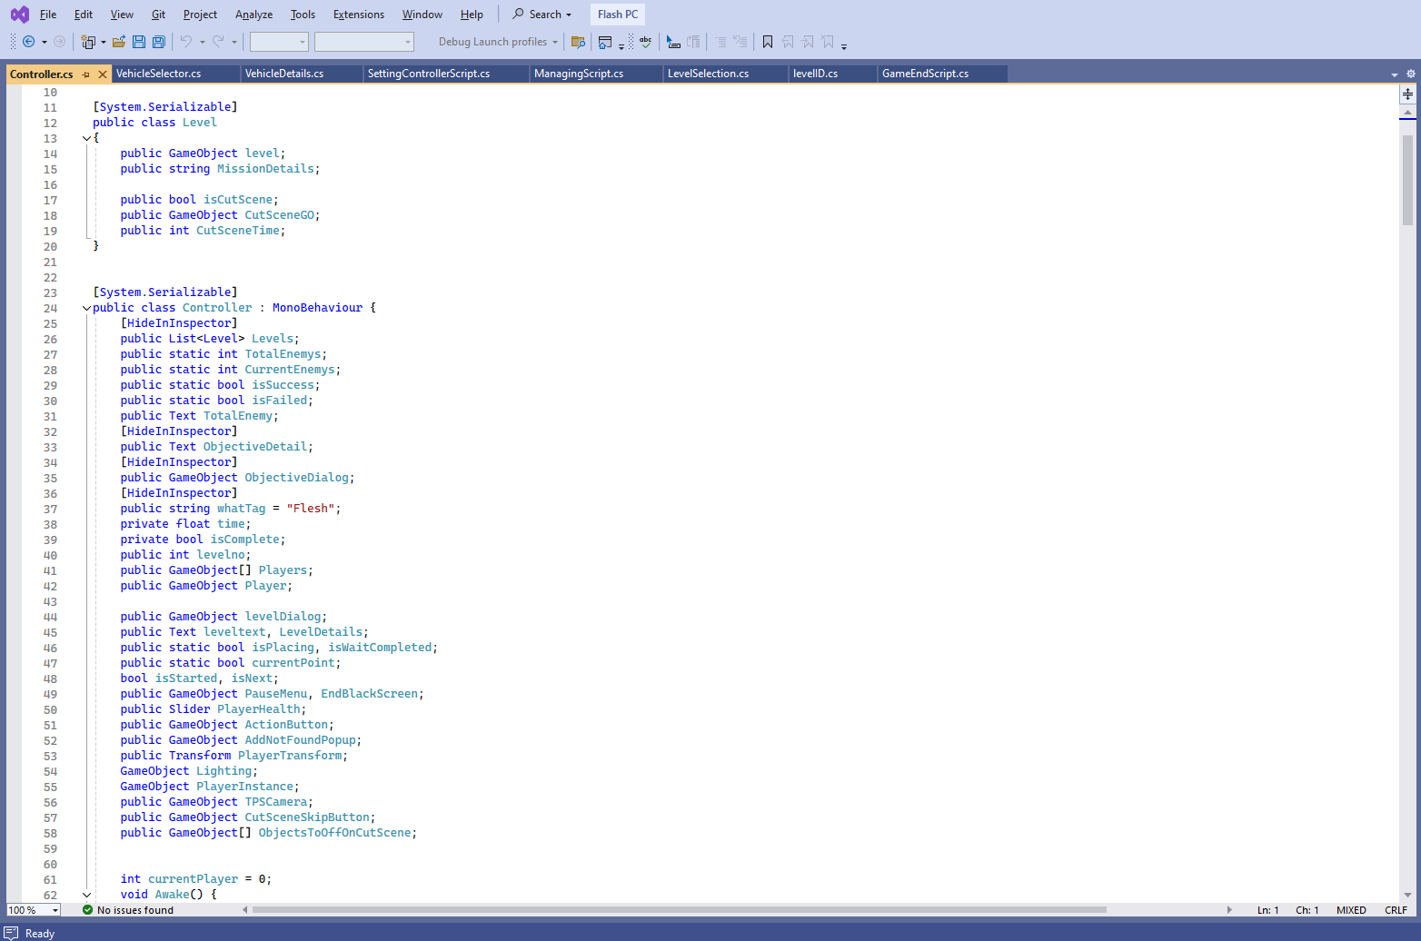

Controller class-2
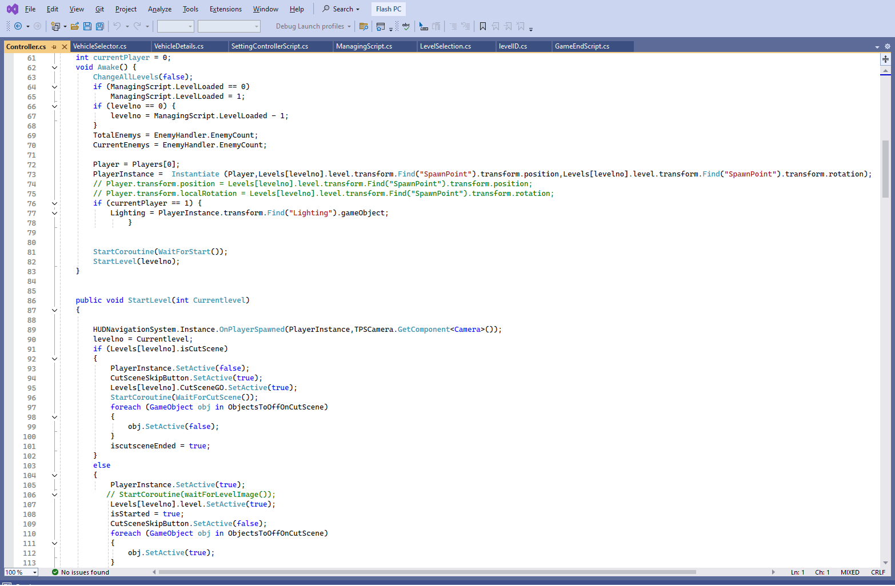

Enemy destroy Class:
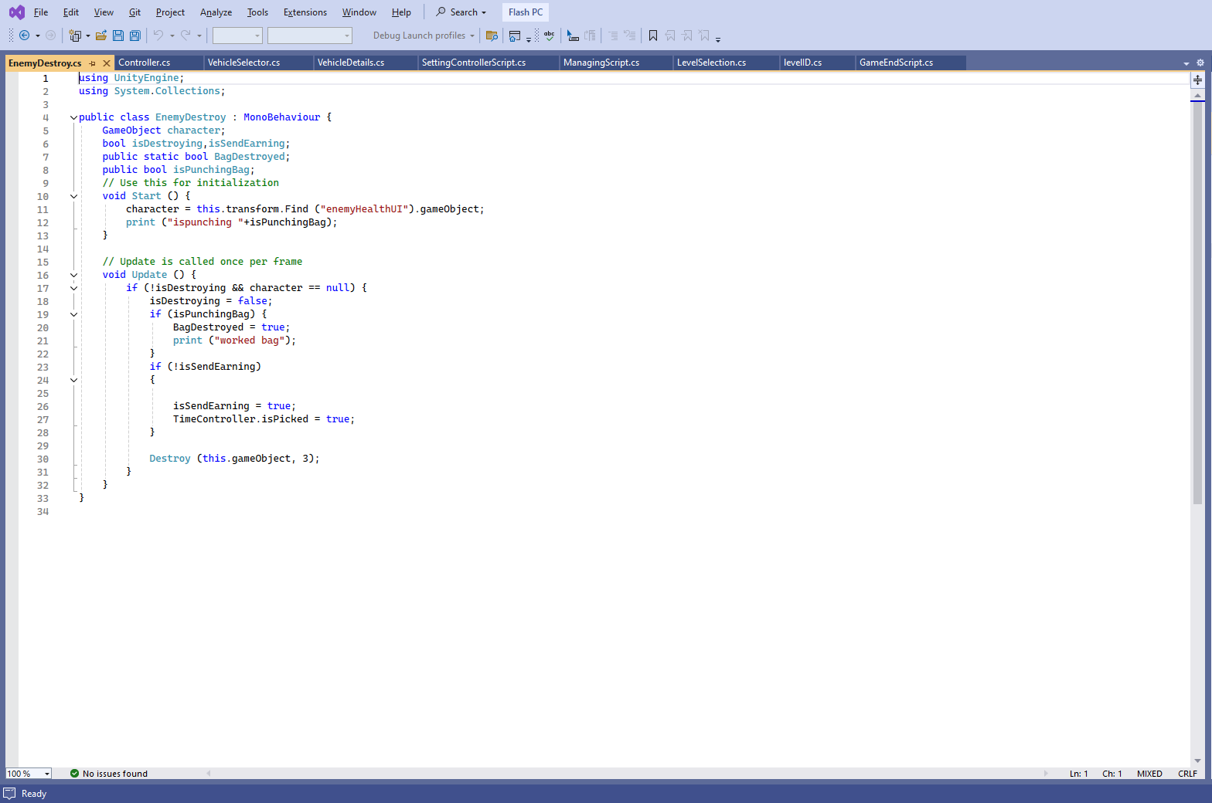
Exit Controller Class:
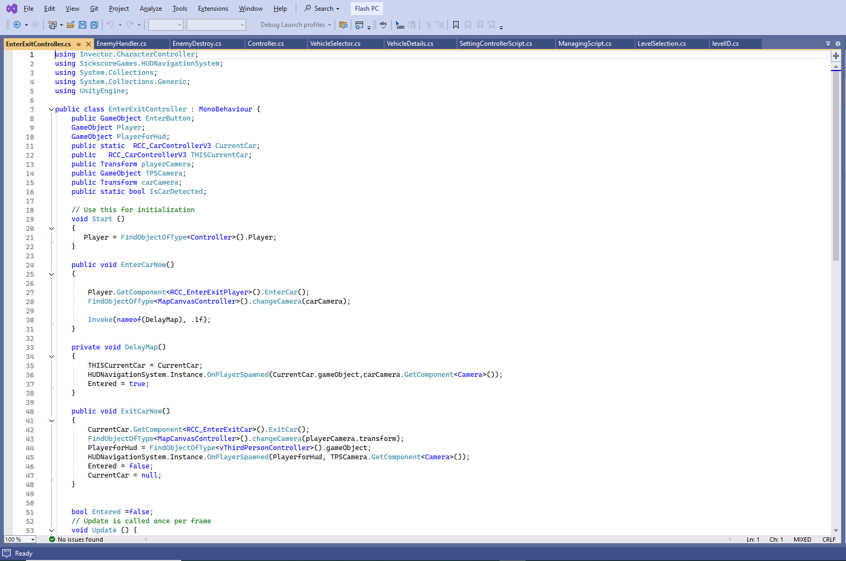

Inventory Class:
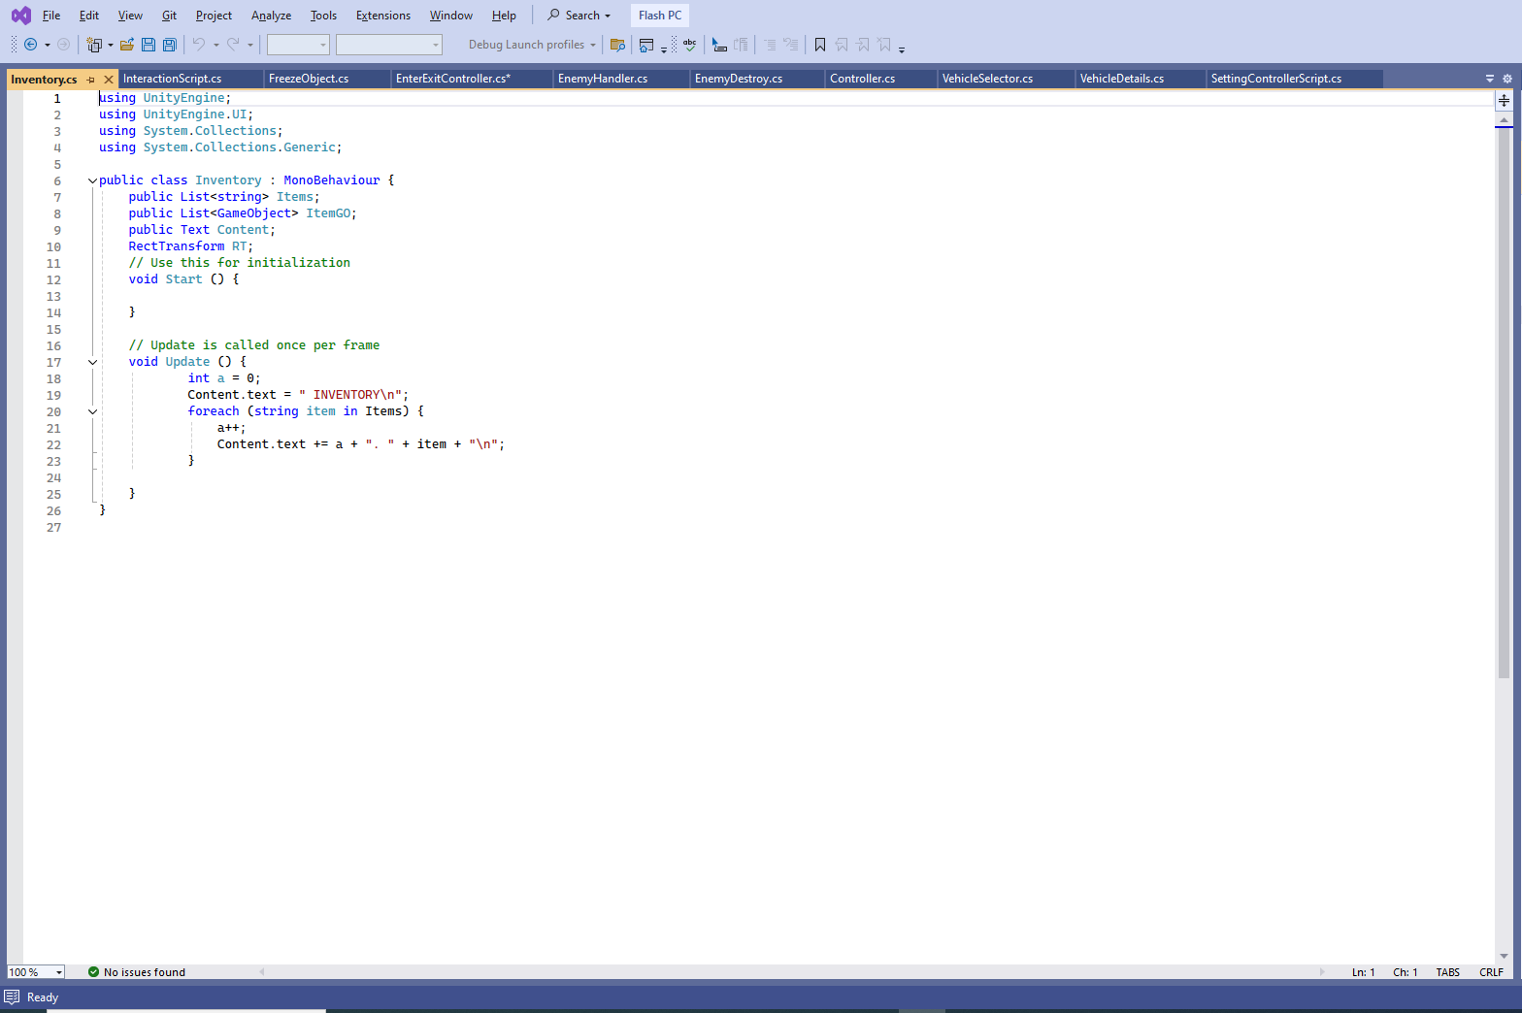
Level ID Class:
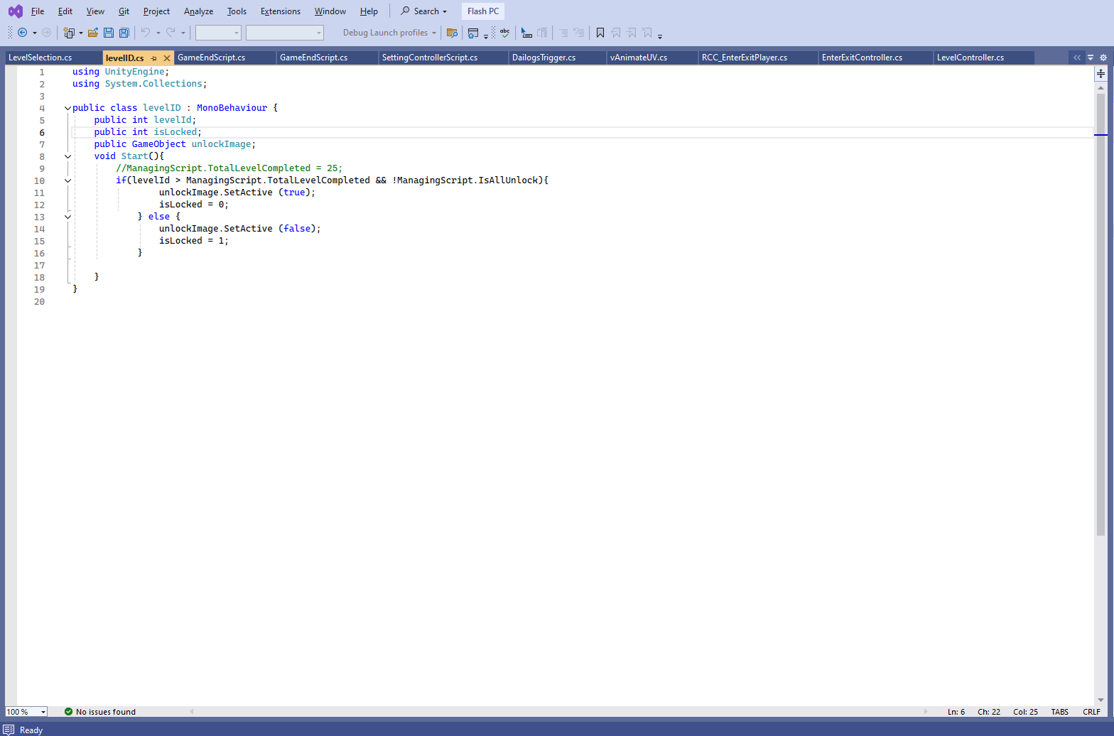

Level Selection Class:
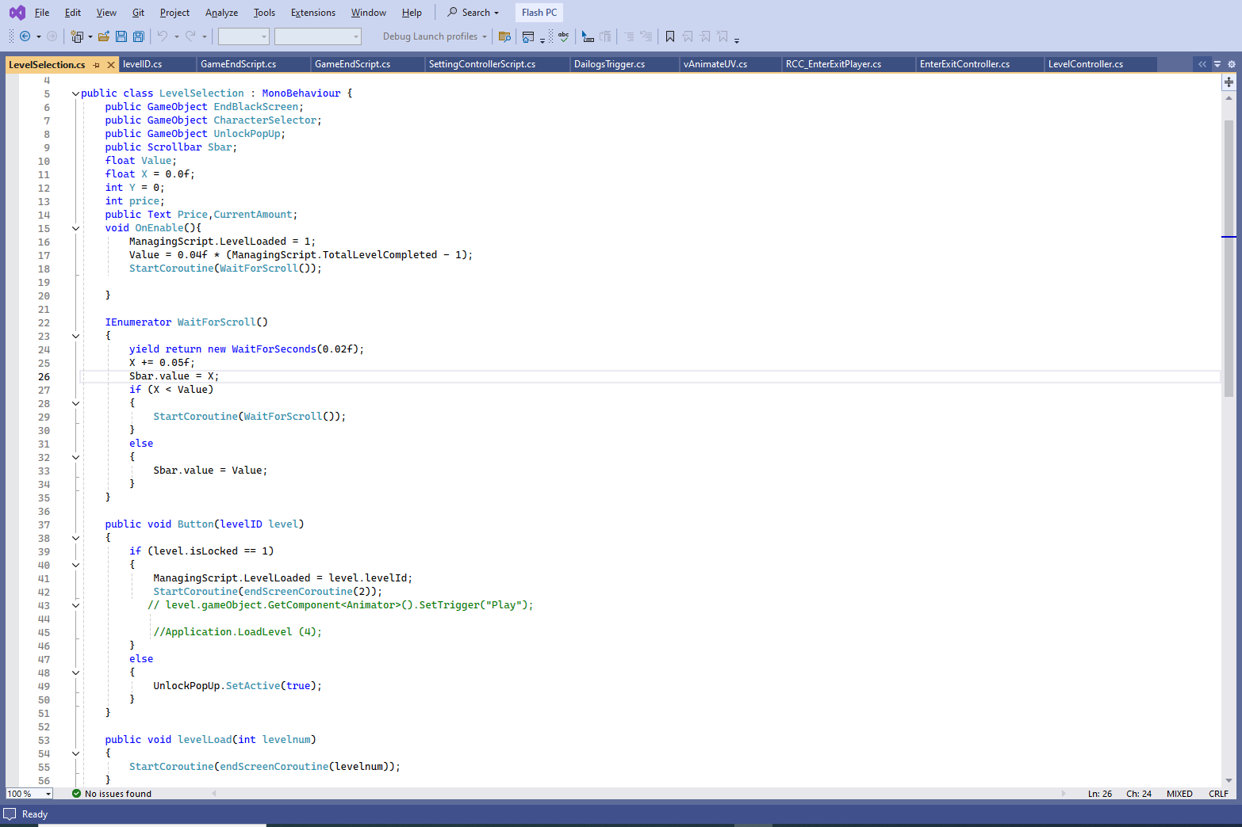
Level Controller Class:
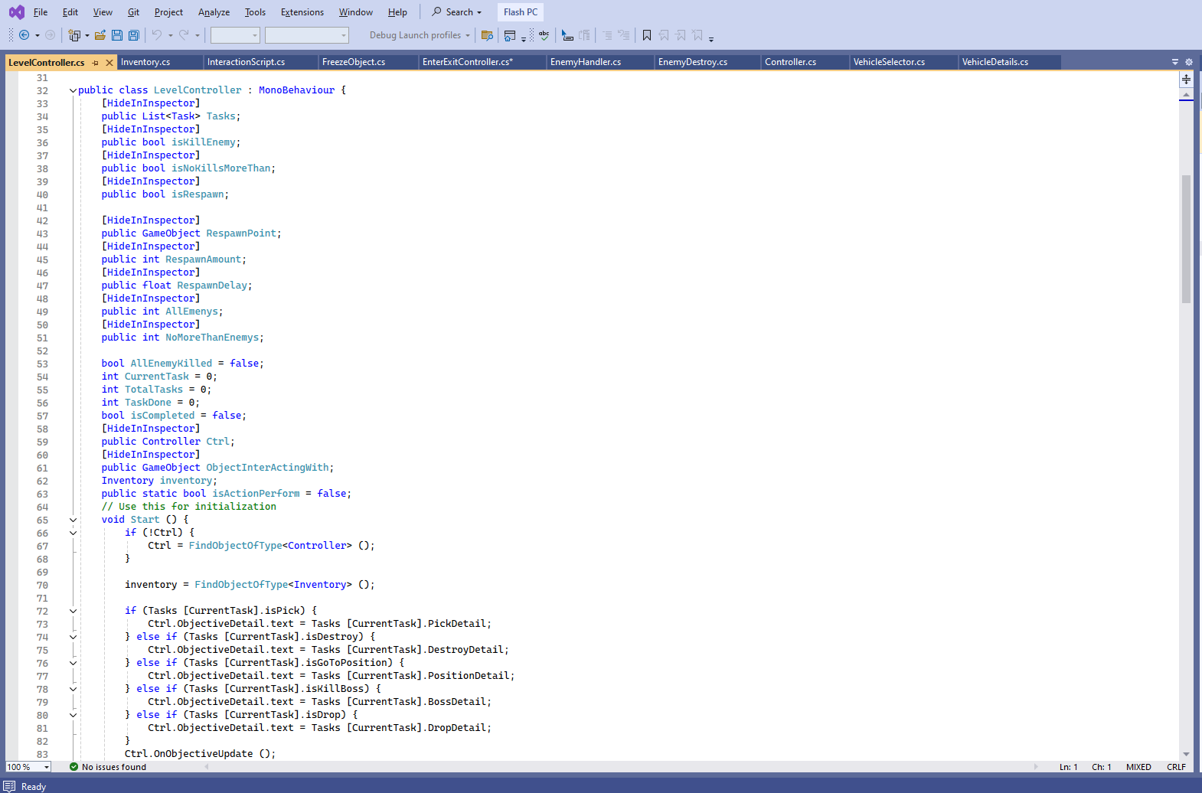
Managing Scripts Class:
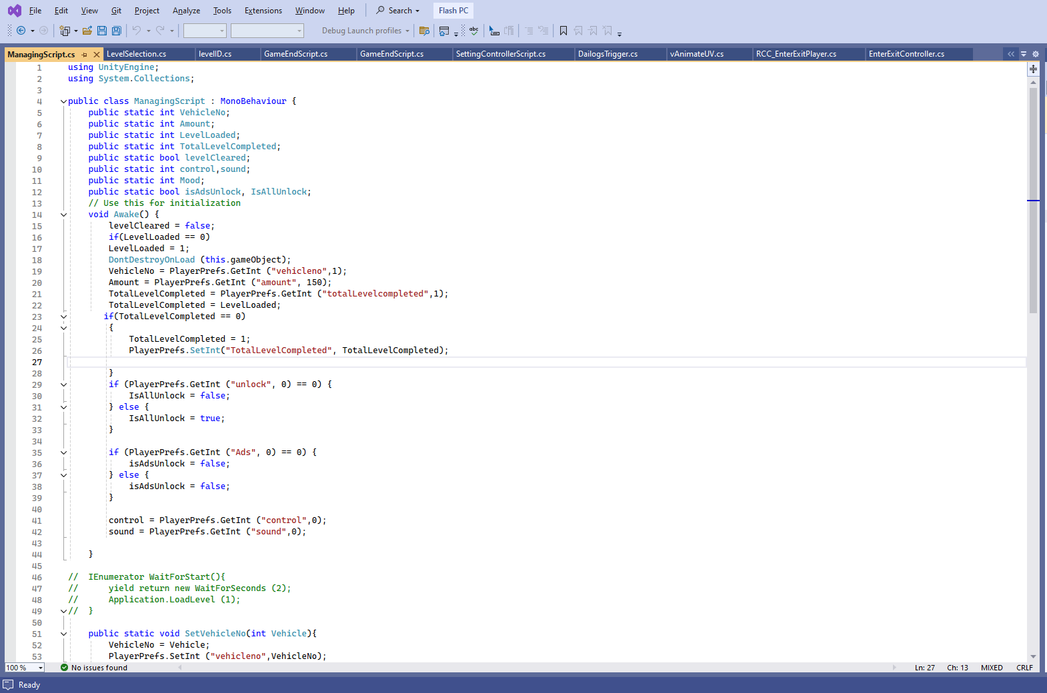
Point Script Class:
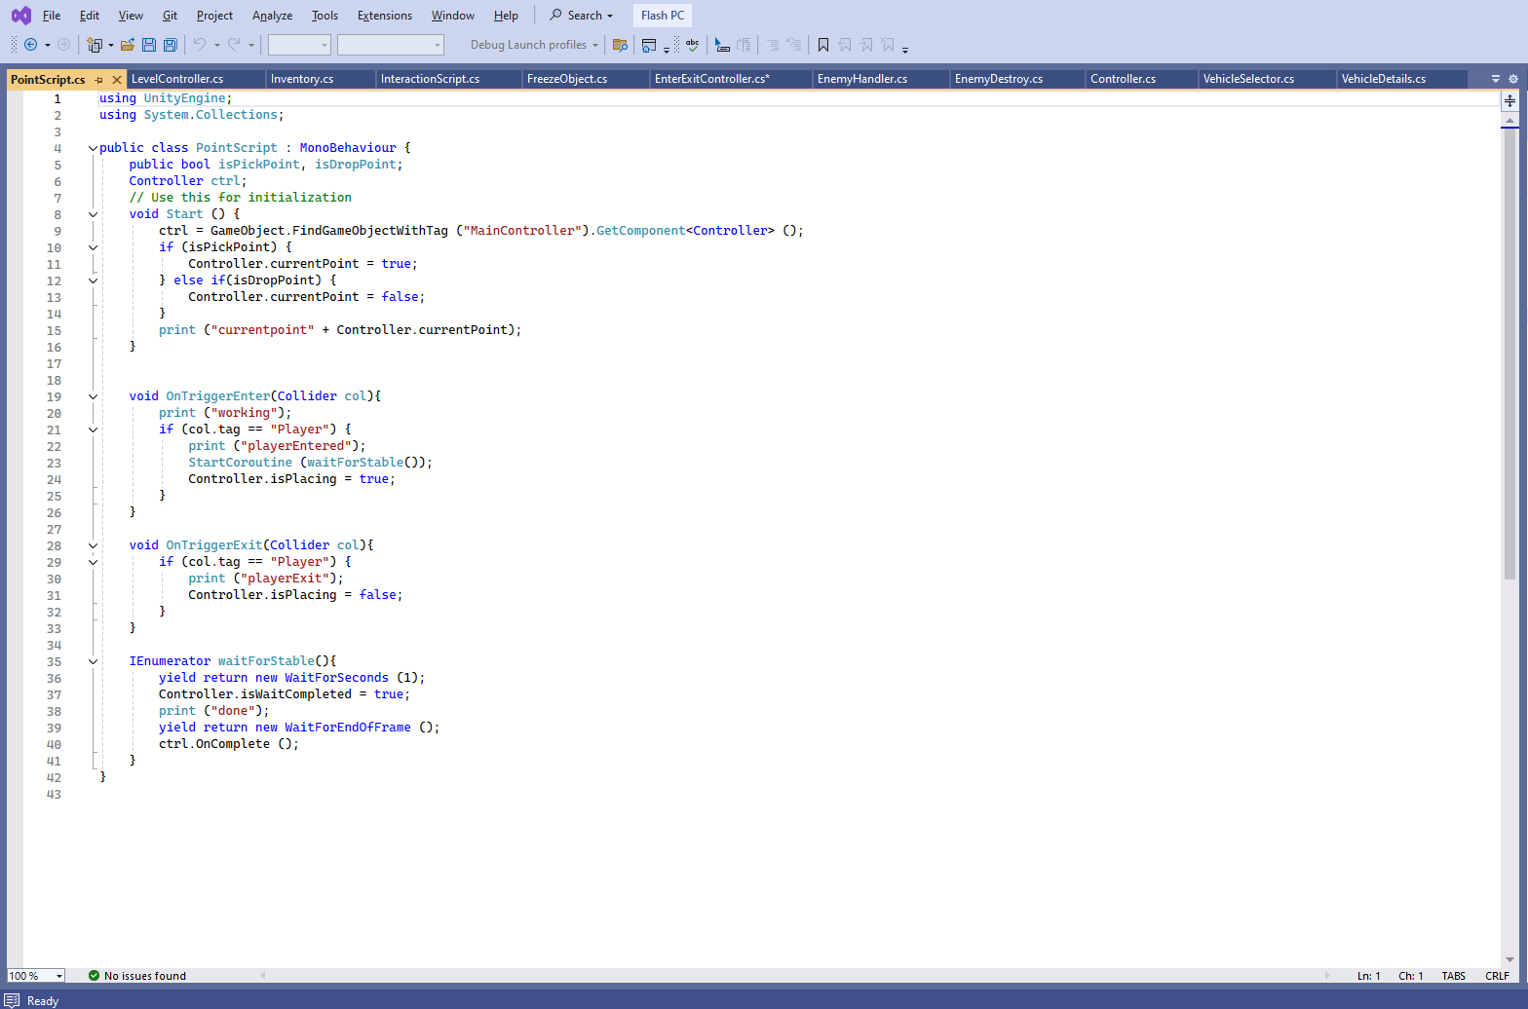
Time Controller Class:
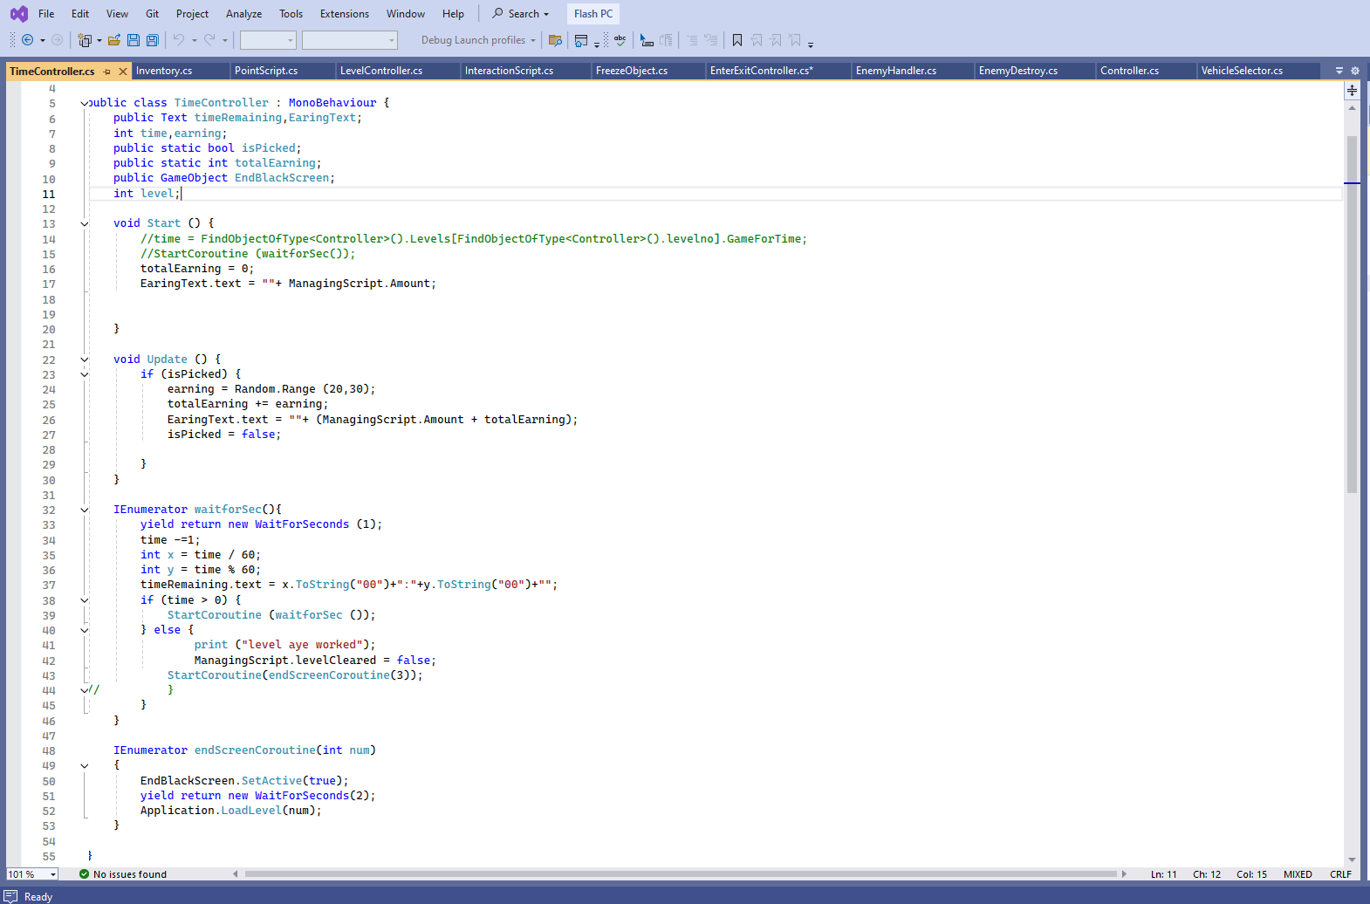
Vehicle Selection Class-1:
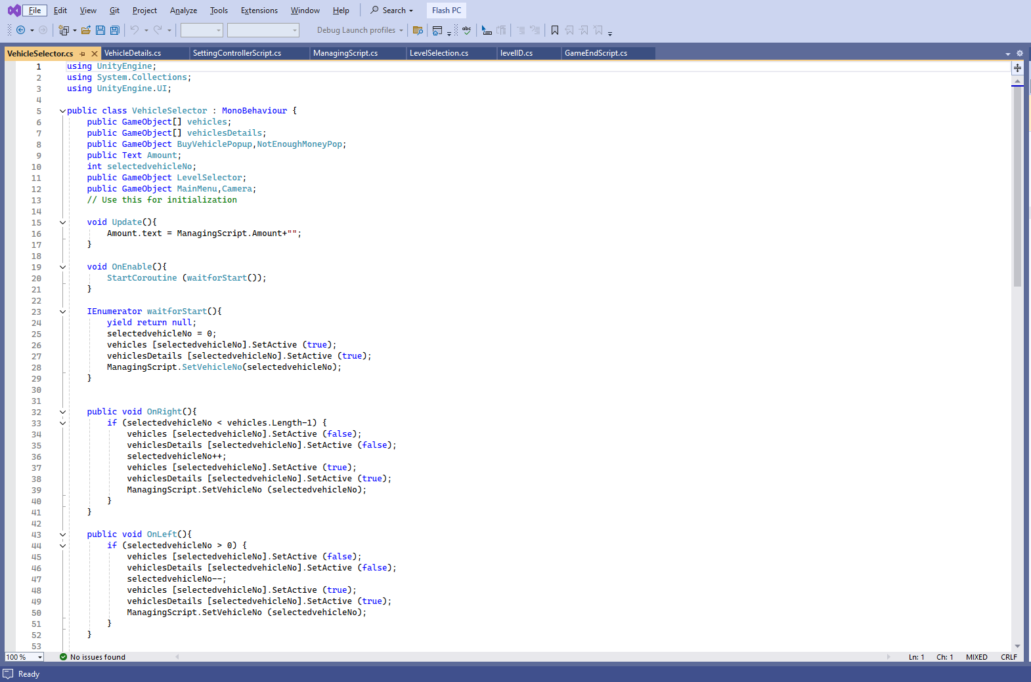
Vehicle Selection Class-2:
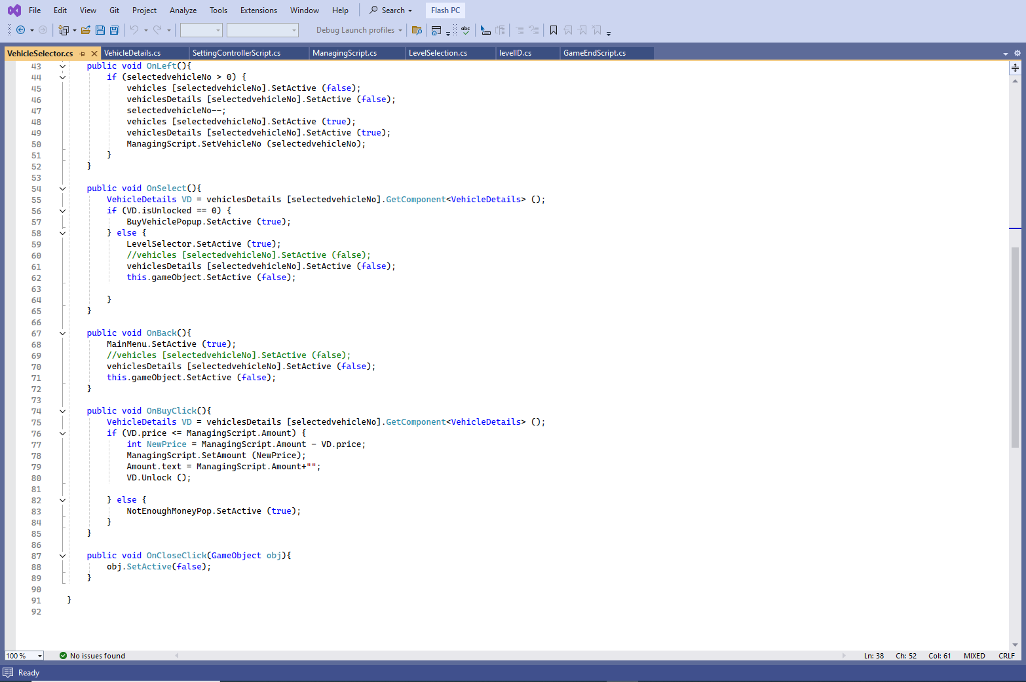
Vehicle details Class:
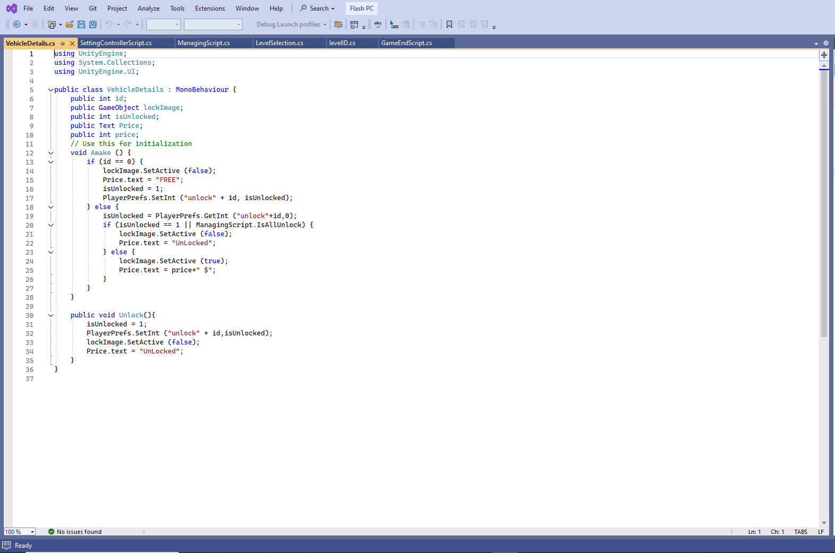
6.2 Introduction
This chapter provides detailed system models and flow diagrams that illustrate the dynamic behavior and interactions within the "Flash Supersonic" game. These diagrams serve as visual aids to understand the system's workflow, data flow, and user interactions, ensuring clarity in design and implementation.
6.3 Use Case Diagram
Figure-3
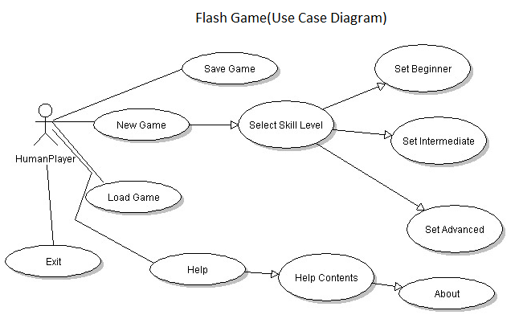

Figure-4

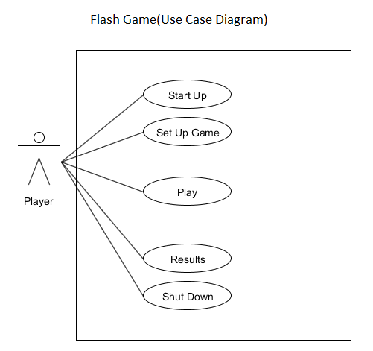

Figure-5

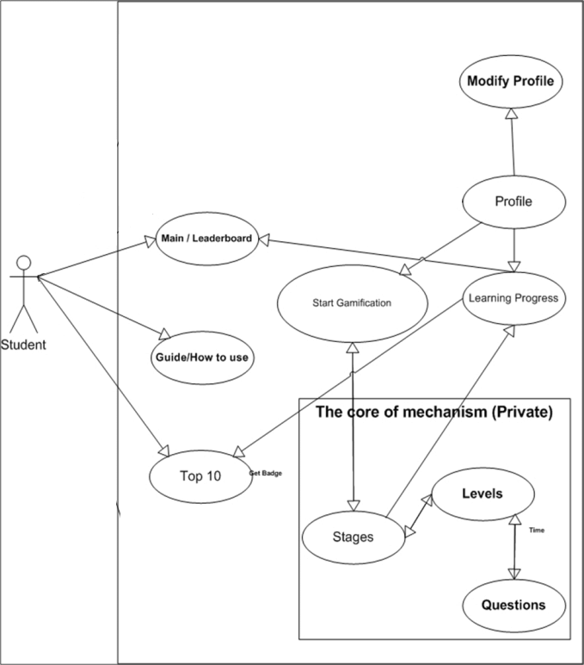

The Flash Adventures game encompasses a variety of key use cases that enhance player engagement and experience. Firstly, player registration and login are fundamental steps, allowing users to create accounts and log in to access the game's features. This initial stage is crucial for managing player data and ensuring personalized gameplay experiences. Once logged in, players proceed to character selection, where they can choose and customize their superhero characters, tailoring appearance and abilities to their preferences, which adds a personalized touch to the gameplay.
Following character selection, players engage in missions, which form the core of the game's narrative and action. Mission engagement involves starting new missions, progressing through various challenges, and ultimately completing them to advance the storyline and unlock rewards. The combat system is integral to mission engagement, as players face off against enemies and bosses, utilizing their character's unique abilities and strategies to triumph in battles.
Exploration is another significant aspect, as players navigate the open-world environment, uncovering secrets, and encountering dynamic events that add depth to the game world. This exploration is complemented by inventory management, where players handle their collection of items and power-ups. Effective inventory management is essential for maintaining an edge in combat and ensuring that players are well-prepared for the challenges ahead.
Multiplayer interaction enriches the gaming experience by allowing players to team up with others, fostering cooperation and competition within the game community. Players can form alliances, tackle missions together, and engage in cooperative or competitive multiplayer modes. Lastly, the game includes a settings and preferences feature, enabling players to configure various game settings such as audio, graphics, and controls to suit their individual preferences. This customization ensures a comfortable and optimized gaming experience for every player. Overall, these key use cases collectively create a comprehensive and immersive gameplay experience in Flash Adventures.
6.4 Mission Engagement
The process of engaging in a mission in Flash Adventures is meticulously detailed in the accompanying activity diagram, illustrating each step from selection to completion. The journey begins with the start phase, initiating the sequence of actions leading the player into an immersive mission.
The first actionable step is to select a mission, where players choose from available missions based on their progress, preferences, or game narrative. This selection is critical as it sets the stage for the ensuing gameplay experience.
Upon selecting a mission, the game proceeds to load the mission environment, a vital step that prepares the game world, rendering the mission-specific landscape, characters, and scenarios. This phase ensures that the player is seamlessly transported into the mission’s setting, ready to embark on the objectives.
Once the environment is loaded, the player engages in the core gameplay: completing mission objectives. These objectives can vary widely, including defeating enemies, rescuing characters, collecting items, or solving puzzles. The successful completion of these objectives is essential for mission progress and directly impacts the player's advancement within the game.
Upon fulfilling all mission objectives, the mission reaches the mission complete status. This milestone signifies the player's success and transitions the game into the reward phase.
Players then receive rewards, which can include in-game currency, items, experience points, or other bonuses that enhance their character's abilities or inventory. These rewards are a key motivational element, providing tangible benefits and encouraging continued engagement with the game.
The process concludes with the end phase, marking the completion of the mission sequence. The player is then free to select another mission or engage in other game activities, continually progressing through the game’s expansive world.
This structured approach ensures a smooth and engaging mission experience, combining strategic selection, immersive gameplay, and rewarding outcomes to keep players invested in Flash Adventures.
6.5 Sequence Diagrams

6.5.1 Combat Interaction
In Flash Adventures, the combat interaction is a critical component, showcasing the dynamic and engaging nature of the game's battle system. This sequence diagram outlines the interaction between the player, AI enemies, and the game system during combat, ensuring a comprehensive understanding of each step involved in the process.
- Player Initiates Combat: The sequence begins with the player initiating combat. This action can occur through various triggers, such as approaching an enemy, entering a combat zone, or selecting an attack option from the menu. The initiation sets the combat sequence in motion, signaling the game system to prepare for battle.
- System Processes Combat Input: Once combat is initiated, the system processes the player's combat input. This includes interpreting the player's commands, such as selecting an attack, using an item, or executing a special move. The system ensures that the inputs are valid and prepares the corresponding actions.
- AI Responds to Player Actions: Following the player's input, the AI enemies respond accordingly. The AI's response is based on predefined behavior patterns, strategic calculations, and the current combat scenario. The enemies may choose to attack, defend, evade, or use special abilities, adding a layer of challenge and unpredictability to the combat.
- Calculate Damage and Effects: The next step involves calculating the damage and effects resulting from both the player's and AI's actions. This calculation considers various factors, including the characters' attributes, the power of the attacks, and any applicable status effects. The system ensures that the damage is accurately determined, contributing to a fair and balanced combat experience.
- Update Player and Enemy Status: After calculating the damage and effects, the system updates the status of both the player and the enemies. This includes adjusting health points, applying status changes (such as poison or stun), and updating any relevant combat statistics. The updated status is crucial for reflecting the current state of the battle and informing subsequent actions.
- End Combat: The combat sequence concludes with the end combat phase. This occurs when either the player or the enemies are defeated, or when certain conditions are met (such as fleeing from battle). The system processes the outcome, rewarding the player with experience points, items, or other benefits if victorious, and potentially triggering additional game events or narrative progressions.
By following this detailed sequence, Flash Adventures ensures a smooth, engaging, and strategically rich combat experience, enhancing the overall gameplay and keeping players immersed in the thrilling world of superheroes and villains.

6.6 Sub-Processes:

Player Registration and Authentication:
This sub-process is critical for ensuring secure access to the game. This process begins with the player providing registration details, such as username, password, and email. The system validates this information to check for uniqueness and compliance with security standards. Once validated, the data is stored in the user database, and an account is created. During login, the system verifies the entered credentials against stored data. Successful authentication grants access, while failed attempts prompt error messages, ensuring only authorized users can play.

Mission Selection and Loading:
The Mission Selection and Loading sub-process allows players to choose and initiate missions. It starts with the player accessing the mission menu, where available missions are displayed along with relevant details such as difficulty, rewards, and objectives. Upon selection, the system retrieves mission-specific data, including environment settings, enemy configurations, and narrative elements. This data is then loaded into the game engine, preparing the environment for the player. This sub-process ensures that each mission begins with the correct parameters and narrative context, providing a seamless transition from selection to gameplay.

Combat Mechanics and AI:
This AI sub-process is responsible for managing in-game combat interactions. This involves processing player inputs, such as attacks and defenses, and determining their effects based on predefined rules and character stats. Simultaneously, the AI system governs enemy behaviors, making decisions on attacks, movements, and tactics to challenge the player. The system continuously updates health, status effects, and other combat variables in real-time. This dynamic interaction between player and AI ensures a challenging and engaging combat experience, reflecting the player’s skills and strategies against intelligent adversaries.

Inventory and Item Management:
This sub-process handles the player’s inventory system. Players can collect, use, and manage items such as weapons, health packs, and power-ups. This process includes adding items to the inventory upon collection, displaying the inventory interface, and allowing players to equip or use items. The system tracks item quantities, effects, and cooldowns, updating the inventory status accordingly. This sub-process ensures that players can effectively manage their resources, strategically using items to enhance their abilities and survive challenging scenarios within the game.

Multiplayer Session Management:
This sub-process facilitates the creation and management of multiplayer game sessions. Players can request to join or create a multiplayer match, prompting the system to search for compatible matches or initialize a new session. This includes synchronizing game states across all connected players, ensuring a cohesive and fair gaming experience. The process handles player connections, in-game communication, and session persistence, managing data flow to maintain real-time interaction. This sub-process is crucial for delivering a seamless multiplayer experience, allowing players to team up, compete, and interact in the shared game world.
6.7 Gameplay States:

1. Idle
The Idle state occurs when the player's character is not performing any active movements or actions. This state is typically characterized by the character standing still, possibly with some idle animations to maintain visual interest. During this state:
The character might perform subtle movements such as breathing, looking around, or shifting weight.
Background processes like ambient sound and environmental animations continue to run.
The game awaits player input to transition to another state, such as movement commands or interactions with objects.

2. Exploring
The Exploring state is when the player is actively navigating the game world. This involves moving the character through various environments, interacting with objects, and discovering new areas. Key features of this state include:
Player controls allow movement in different directions, sprinting, jumping, and other traversal actions.
Interactive elements in the environment, such as NPCs (Non-Playable Characters), items, and clues, become accessible.
The game world dynamically loads new areas and assets as the player progresses to maintain a seamless exploration experience.
The HUD (Heads-Up Display) may display a minimap, objectives, and other relevant information to aid the player in navigation.
3. In Combat
The in-Combat state is triggered when the player encounters enemies and engages in battles. This state focuses on action-packed gameplay, requiring quick reflexes and strategic decision-making. Characteristics of this state include:
Combat mechanics such as attacking, dodging, blocking, and using special abilities are activated.
Enemy AI becomes aggressive, attacking the player with various tactics and behaviors.
Health bars, status effects, and combat-related UI elements are prominently displayed.
Audio cues like battle music and sound effects enhance the intensity of the combat experience.

4. Completing Mission
The Completing Mission state occurs when the player reaches the end of a mission or achieves specific objectives. This state often includes:
Cut scenes or dialogues that conclude the mission's narrative and provide context for the next objectives.
Rewards such as experience points, items, and unlockable content are granted to the player.
The game may save the player's progress and update mission logs or records.
Transitioning to a new mission, returning to a base or safe area, or providing options for free exploration.

Chapter 7 Results and Discussion
7.1 Results
The development and implementation of our Flash game project, which is centered on superhero gameplay, have yielded significant insights and outcomes. Throughout the project, we meticulously adhered to our design specifications and implemented a comprehensive suite of features, including player registration and login, character selection, mission engagement, combat systems, exploration, inventory management, multiplayer interaction, and settings configuration. Each of these features was rigorously tested using detailed test cases to ensure functionality, reliability, and user satisfaction.
Our testing phase, conducted between May 25, 2024, and June 2, 2024, revealed that all primary functionalities of the game performed as expected. Key processes such as user registration and login were verified for smooth operation, with successful creation and authentication of user accounts. The character selection process was effective, allowing players to create and customize their superhero avatars, thereby enhancing user engagement and personalization.
Mission engagement was a critical component of our game, and our tests confirmed that players could successfully start, progress through, and complete missions. This included seamless transitions between mission objectives, accurate tracking of player progress, and rewarding players upon mission completion. The combat system, a core gameplay element, was tested extensively. It demonstrated robust interactions between players and AI enemies, with accurate damage calculation and status updates ensuring a dynamic and challenging combat experience.
Exploration in the game’s open-world environment was another highlight. Players could navigate through different areas, interact with objects, and experience random events, adding depth to the gameplay. Inventory management was validated to allow efficient organization and usage of items, which is crucial for gameplay strategy and progression.
Multiplayer interaction, including player matching and communication, functioned effectively, providing a cooperative and competitive gameplay experience. Settings and preferences were configurable, allowing players to tailor the game to their liking, which is vital for accessibility and user satisfaction.
Our testing results indicate that the game met all predefined requirements and objectives. The successful implementation of various systems and sub-processes demonstrates the effectiveness of our design and development approach. However, the discussion also highlighted areas for potential enhancement, such as optimizing performance during multiplayer sessions and expanding customization options in character selection.
In conclusion, the project’s outcomes validate our initial design choices and underscore the importance of thorough testing and iterative development. The positive reception of the game’s features suggests a strong foundation for future expansions and improvements. Continued feedback and real-world usage data will be invaluable for refining and enhancing the game, ensuring it remains engaging and enjoyable for players.

7.2 Test Cases
Table 11: Test Case-1
Test Case ID | TC-1
Test Case Name | Player Registration and Login
Test Case Version | 1
QA Test Engineer | Shujat Qamar
Test Date | 25/05/2024
Reviewed By | Talal Khalid
Revision History | No
Objective | Users can register and log in to access the game.
Device | PC/Laptop
Environment | Unity
Expected Result | Successful user registration and login.
Pre-Requisite | Internet connection.
Requirements | User database.
Comments | Passed
Status | ☑️ Passed ☐ Failed ☐ Not Executed
Table 12: Test Case-2
Test Case ID | TC-2
Test Case Name | Character Selection
Test Case Version | 1
QA Test Engineer | Talal Khalid
Test Date | 26/05/2024
Reviewed By | Shujat Qamar
Revision History | No
Objective | Players can select and customize their superhero character.
Device | PC/Laptop
Environment | Unity
Expected Result | Successful character selection and customization.
Pre-Requisite | User login.
Requirements | Character database.
Comments | Passed
Status | ☑️ Passed ☐ Failed ☐ Not Executed
Table 13: Test Case-3
Test Case ID | TC-3
Test Case Name | Mission Engagement
Test Case Version | 1
QA Test Engineer | Shujat Qamar
Test Date | 27/05/2024
Reviewed By | Talal Khalid
Revision History | No
Objective | Players can start, progress through, and complete missions.
Device | PC/Laptop
Environment | Unity
Expected Result | Successful mission engagement and completion.
Pre-Requisite | Character selection.
Requirements | Mission database.
Comments | Passed
Status | ☑️ Passed ☐ Failed ☐ Not Executed

Table 14: Test Case-4
Test Case ID | TC-4
Test Case Name | Combat System
Test Case Version | 1
QA Test Engineer | Talal Khalid
Test Date | 28/05/2024
Reviewed By | Shujat Qamar
Revision History | No
Objective | Players can engage in combat with enemies and bosses.
Device | PC/Laptop
Environment | Unity
Expected Result | Successful combat interaction and outcome.
Pre-Requisite | Mission engagement.
Requirements | Combat AI and logic.
Comments | Passed
Status | ☑️ Passed ☐ Failed ☐ Not Executed

Table 15: Test Case-5
Test Case ID | TC-5
Test Case Name | Exploration
Test Case Version | 1
QA Test Engineer | Shujat Qamar
Test Date | 29/05/2024
Reviewed By | Talal Khalid
Revision History | No
Objective | Players can explore the open-world environment.
Device | PC/Laptop
Environment | Unity
Expected Result | Successful exploration without glitches.
Pre-Requisite | User login.
Requirements | World map and assets.
Comments | Passed
Status | ☑️ Passed ☐ Failed ☐ Not Executed
Table 16: Test Case-6
Test Case ID | TC-6
Test Case Name | Inventory Management
Test Case Version | 1
QA Test Engineer | Talal Khalid
Test Date | 30/05/2024
Reviewed By | Shujat Qamar
Revision History | No
Objective | Players can manage their inventory, including items and power-ups.
Device | PC/Laptop
Environment | Unity
Expected Result | Successful inventory management.
Pre-Requisite | User login.
Requirements | Inventory database.
Comments | Passed
Status | ☑️ Passed ☐ Failed ☐ Not Executed

Table 17: Test Case-7
Test Case ID | TC-7
Test Case Name | Multiplayer Interaction
Test Case Version | 1
QA Test Engineer | Shujat Qamar
Test Date | 31/05/2024
Reviewed By | Talal Khalid
Revision History | No
Objective | Players can interact and team up with other players.
Device | PC/Laptop
Environment | Unity
Expected Result | Successful multiplayer interactions.
Pre-Requisite | User login.
Requirements | Multiplayer server.
Comments | Passed
Status | ☑️ Passed ☐ Failed ☐ Not Executed

Table 18: Test Case-8
Test Case ID | TC-8
Test Case Name | Settings and Preferences
Test Case Version | 1
QA Test Engineer | Talal Khalid
Test Date | 01/06/2024
Reviewed By | Shujat Qamar
Revision History | No
Objective | Players can configure game settings and preferences.
Device | PC/Laptop
Environment | Unity
Expected Result | Successful update and storage of settings.
Pre-Requisite | User login.
Requirements | Settings database.
Comments | Passed
Status | ☑️ Passed ☐ Failed ☐ Not Executed

Chapter 8 Conclusion and Future Work
8.1 Conclusion:
The journey of developing our Flash game, centered on superhero gameplay, has been both challenging and rewarding. Through diligent planning, design, and execution, we successfully created a game that encompasses various engaging features such as player registration, character customization, mission engagement, combat, exploration, inventory management, multiplayer interaction, and configurable settings. The extensive testing phase confirmed that the game operates smoothly and meets the objectives set forth at the beginning of the project.
Our results indicate that the game is not only functional but also enjoyable and engaging for players. The success of the core features, particularly in mission engagement and combat systems, highlights the effectiveness of our development process. The project has also provided valuable insights into game design and development, particularly in areas such as user interaction, system integration, and feature implementation.
Overall, the project has achieved its primary goals and laid a strong foundation for further enhancements. The positive feedback received from the testing phase underscores the potential of the game to be a popular and engaging entertainment option.
8.2 Future Work
While the current version of the game has met its objectives, there is always room for improvement and expansion. Future work on the project will focus on several key areas to enhance the player experience and expand the game's capabilities:
8.2.1 Performance Optimization:
Address any performance bottlenecks, particularly in multiplayer sessions, to ensure smooth and seamless gameplay.
Optimize load times and reduce lag to enhance the overall player experience.
8.2.2 Expanded Customization Options:
Introduce more customization options for characters, including new outfits, abilities, and accessories.
Allow for more detailed customization to enable players to create truly unique superhero avatars.
8.2.3 Enhanced AI and Enemy Interactions:
Improve the AI behavior to make enemies more challenging and adaptive to player strategies.
Introduce new types of enemies and bosses with unique abilities and attack patterns.
8.2.4 Additional Missions and Content:
Develop new missions and storylines to keep the gameplay fresh and engaging.
Add more diverse environments and mission objectives to enhance variety.
8.2.5 Social and Community Features:
Implement social features such as friend lists, chat functionality, and leaderboards to foster a sense of community.
Allow players to form teams and guilds to enhance cooperative gameplay.
8.2.6 Regular Updates and Events:
Plan for regular content updates and special events to keep the game dynamic and engaging.
Introduce seasonal events and limited-time challenges to maintain player interest.
8.2.7 Cross-Platform Compatibility:
Explore the possibility of making the game available on multiple platforms, including mobile devices and consoles.
Ensure a consistent and enjoyable experience across different devices.
8.2.8 User Feedback Integration:
Continuously gather and analyze player feedback to identify areas for improvement.
Implement changes and enhancements based on user suggestions to ensure the game remains player-focused.
By focusing on these areas, we aim to not only maintain but also enhance the game's appeal and longevity. The insights gained from this project will serve as a valuable foundation for future development efforts, ensuring that the game evolves in line with player expectations and industry standards. With continued dedication and innovation, we are confident that our Flash game will continue to captivate and entertain players for years to come.

References:
- GeeksforGeeks. (2022). MERN Stack. Retrieved from https://www.geeksforgeeks.org/mern-stack/
- Relevant Software. (2022). Human Resource Management Software Development. Retrieved from https://relevant.software/blog/develop-human-resource-management-software/
- BrainyHR. (2022). Must-Have Features of Human Resource Management System. Retrieved from https://brainyhr.io/blog/6-must-have-features-of-human-resource-management-system.html
- NetSuite. (2022). Human Resources Management System (HRMS). Retrieved from https://www.netsuite.com/portal/resource/articles/human-resources/human-resources-management-system-hrms.shtml
- Oodles ERP Solutions. (2022). Tech Stack for Web Development in 2021. Retrieved from https://erpsolutions.oodles.io/blog/tech-stack-web-development-2021/
- Johnson, M. (2022). Getting Started with Visual Studio: A Comprehensive Guide. Microsoft Visual Studio Documentation. Retrieved from https://docs.microsoft.com/en-us/visualstudio/
- Adams, R. (2022). Exploring the Power of C#: An Introduction to the C# Programming Language. C# Programming Blog. Retrieved from https://www.c-sharpcorner.com/
- Thompson, S. (2022). The Art of Gaming: Understanding Game Development Principles. Game Development Magazine. Retrieved from https://www.gamedevelopmentmagazine.com/
- Roberts, L. (2022). Mastering Unity: A Comprehensive Guide to Unity Game Development. Unity Documentation. Retrieved from https://docs.unity3d.com/
- Game Alchemy: Crafting Success with C# and Unity's Dynamic Partnership. Retrieved from https://www.researchgate.net/publication/377395478_Indie_Game_Alchemy_Crafting_Success_with_C_and_Unity%27s_Dynamic_Partnership

- Create Interactive Gaming Experiences with Unity Development. Retrieved from https://www.emizentech.com/blog/game-development-with-unity.html

- A One-Stop Solution Guide To Understanding C# Unity And Its User Interface. Retrieved from https://www.simplilearn.com/tutorials/c-sharp-tutorial/guide-to-c-sharp-unity-and-user-interface

- Pro Unity Game Development with C#. Retrieved from https://link.springer.com/book/10.1007/978-1-4302-6745-4

- Unity Game Development Guidelines: Build Unity Game. Retrieved from https://riseuplabs.com/unity-game-development-guidelines/

- The Ultimate Beginners Guide To Game Development In Unity. Retrieved from https://www.freecodecamp.org/news/the-ultimate-beginners-guide-to-game-development-in-unity-f9bfe972c2b5/

- Unity. Retrieved from https://www.c-sharpcorner.com/technologies/unity

- Is Unity necessary for C# developers to make a game? Retrieved from https://www.quora.com/Is-Unity-necessary-for-C-developers-to-make-a-game-Ive-been-trying-to-understand-Unity-for-almost-4-years-but-today-I-saw-a-video-which-critizes-Unity-Is-there-an-another-way-to-make-game-without-Unity

- C# Programming for Unity Game Development Specialization. Retrieved from https://www.coursera.org/specializations/programming-unity-game-development

- Introduction to Unity: Independent Game Programming with C#. Retrieved from https://www.researchgate.net/publication/329277859_Introduction_to_Unity_Independent_Game_Programming_with_C

- Unity C# Game Development 101: Learn by making games (2022). Retrieved from https://www.udemy.com/course/unity-game-development-101/?utm_source=adwords&utm_medium=udemyads&utm_campaign=DSA_Catchall_la.EN_cc.ROW&campaigntype=Search&portfolio=ROW-English&language=EN&product=Course&test=&audience=DSA&topic=&priority=&utm_content=deal4584&utm_term=_._ag_88010211481_._ad_535397282061_._kw__._de_c_._dm__._pl__._ti_dsa-392722865168_._li_1011082_._pd__._&matchtype=&gad_source=1&gclid=EAIaIQobChMIyMSh-bLVhgMVaGZBAh3qQQUuEAMYASAAEgJa0PD_BwE&couponCode=2021PM25

ORIGINALITY REPORT
12

%
SIMILARITY INDEX

9%
INTERNET SOURCES

1%
PUBLICATIONS

9%
STUDENT PAPERS

PRIMARY SOURCES

1 Submitted to Higher Education Commission Pakistan
Student Paper

www.slideshare.net
2
Internet Source

Submitted to University of Lancaster
3
Student Paper

www.coursehero.com
4
Internet Source

Submitted to University of Westminster
5
Student Paper

Submitted to University of Leicester
6
Student Paper

Submitted to Glyndwr University
7
Student Paper

Submitted to University of Sunderland
8
Student Paper

Submitted to CSU, Fullerton
9
Student Paper
2%
1%
1%
<1%
<1%
<1%
<1%
<1%
<1%

10

11

12

13

14

15

16

17

18

19

20
Submitted to Gulf College Oman
Student Paper

Submitted to National College of Ireland
Student Paper

Submitted to Ain Shams University
Student Paper

enbeeone3.com
Internet Source

Submitted to University of Wales Institute, Cardiﬀ
Student Paper

Submitted to Ghana Technology University College
Student Paper

Submitted to Kingston University
Student Paper

docplayer.net
Internet Source

pdfcoﬀee.com
Internet Source

liu.diva-portal.org
Internet Source

Submitted to Cebu Institute of Technology
<1%
<1%
<1%
<1%
<1%
<1%
<1%
<1%
<1%
<1%
<1%

21

22

23

24

25

26

27

28

29

30

31
aaronsmith2474.medium.com
Internet Source

digiprimatech.wordpress.com
Internet Source

ejournal.uin-malang.ac.id
Internet Source

umpir.ump.edu.my
Internet Source

Submitted to Central Queensland University
Student Paper

Submitted to King Fahd University for Petroleum and Minerals
Student Paper

Submitted to OTHM Qualiﬁcations
Student Paper

Submitted to RDI Distance Learning
Student Paper

github.com
Internet Source

brainyhr.io
Internet Source

Submitted to University of Technology, Sydney
<1%
<1%
<1%
<1%
<1%
<1%
<1%
<1%
<1%
<1%
<1%

32

33

34

35

36

37

38

39

40

41

42

43
cs.wikipedia.org
Internet Source

pt.scribd.com
Internet Source

ra.adm.cs.cmu.edu
Internet Source

Submitted to HELP UNIVERSITY
Student Paper

www.ijraset.com
Internet Source

Submitted to Unicaf University
Student Paper

text.123docz.net
Internet Source

Submitted to University of South Australia
Student Paper

en.unionpedia.org
Internet Source

www.scribd.com
Internet Source

Submitted to HCUC
Student Paper

Submitted to Oxford Brookes University
Student Paper
<1%
<1%
<1%
<1%
<1%
<1%
<1%
<1%
<1%
<1%
<1%
<1%

44

45

46

47

48

49

50

51

52

53

54
Submitted to Study Group Australia
Student Paper

Submitted to University of Huddersﬁeld
Student Paper

ejournal.unsrat.ac.id
Internet Source

Submitted to 48370
Student Paper

Submitted to University of East London
Student Paper

Submitted to University of Luton
Student Paper

a4academics.com
Internet Source

Submitted to Henley College Coventry, Coventry
Student Paper

Submitted to The Aacdemy of Korean Studies
Student Paper

aliciapiavis.com
Internet Source

jucmnav.softwareengineering.ca
Internet Source
<1%
<1%
<1%
<1%
<1%
<1%
<1%
<1%
<1%
<1%
<1%

55

56

57

58

59

60

61

62

63

64

65

66
Submitted to Technological Institute of the Philippines
Student Paper

catalog.uttyler.edu
Internet Source

medium.com
Internet Source

open.library.ubc.ca
Internet Source

www.pearltrees.com
Internet Source

www.pjm.com
Internet Source

ijercse.com
Internet Source

www.icsid.org
Internet Source

www.allaboutrequirements.com
Internet Source

Submitted to University of Greenwich
Student Paper

docplayer.cz
Internet Source

ikee.lib.auth.gr
<1%
<1%
<1%
<1%
<1%
<1%
<1%
<1%
<1%
<1%
<1%

67

68

69

70
Internet Source

www.nzta.govt.nz
Internet Source

www.zoho.com
Internet Source

Asma J. Abdulwareth, Asma A. Al-Shargabi. "Toward a Multi-Criteria Framework for Selecting Software Testing Tools", IEEE Access, 2021
Publication

Daniel Galin. "Software Quality: Concepts and Practice", Wiley, 2018
Publication
<1%
<1%
<1%
<1%

<1%

